
Easy Read

Pharmacy services in Milton Keynes

Easy Read


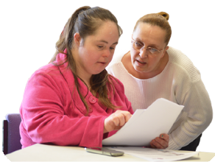
This is an Easy Read version of some information. It may not include all of the information but it will tell you about the important parts.

This Easy Read booklet uses easier words and pictures. Some people may still want help to read it.

Some words are in bold - this means the writing is thicker and darker.
Bold
words
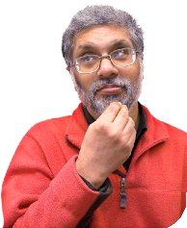
These are important words in the booklet.

This word
means….

Sometimes if a bold word is hard to understand, we will explain what it means.

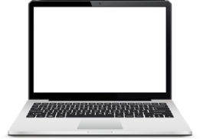

Blue and underlined words show links to websites and email addresses. You can click on these links on a computer.

links

What is in this booklet
About this booklet 4
Looking at pharmacy services 5
About Milton Keynes 7
Pharmacies in Milton Keynes 10
Pharmacy services in Milton Keynes 12
What people told us 15
Ways pharmacy services can be better 18

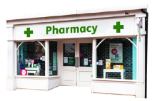
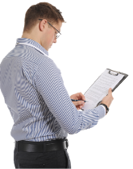
About this booklet

Milton Keynes City Council is looking at pharmacy services in Milton Keynes.

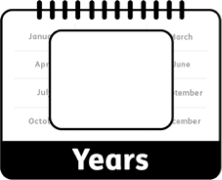
We have to look at pharmacy services every 3 years.
3

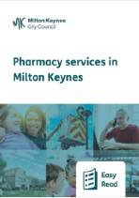
This booklet will tell you what we found out about pharmacy services in Milton Keynes, and how they could be better.

Looking at pharmacy services

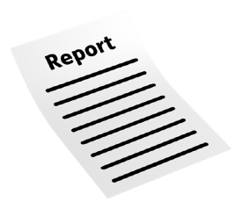
When we look at pharmacy services we write a report called a Pharmaceutical Needs Assessment (PNA).

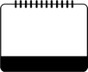
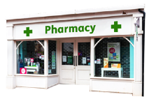
The PNA looks at:
Now

- What pharmacy services we have now.

- What pharmacy services we might need in the future.

Future

We use the PNA to help decide if we can:

New

- Let new pharmacies open.

Change
- Let pharmacies change how they work.


We will use what people tell us about pharmacy services in Milton Keynes when we write our PNA.


About Milton Keynes

Just over 300,000 people live in Milton Keynes.

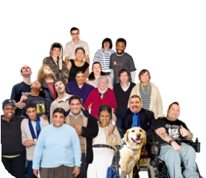
By 2028, we think that about 8,000 more people will live in Milton Keynes.

More

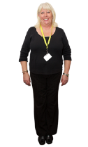
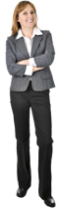

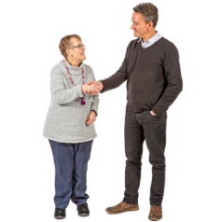
More than half the people who live in Milton Keynes are white, either British or Irish.


We expect men in Milton Keynes to live to about age 80 and women to about age 83.


We expect men and women in Milton Keynes to stay healthy until they are about age 62.


The health of most people in Milton Keynes is about the same as the whole of England.


But this is not the same for everyone.

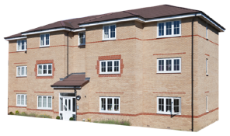
People in Milton Keynes are more likely than people in the rest of England to:

- Be homeless.


People in Milton Keynes are just as likely as people in the rest of England to:

- Be overweight or obese. Obese means very overweight.

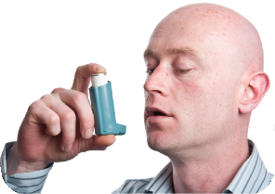
People in Milton Keynes are less likely than people in the rest of England to:

- Have asthma.

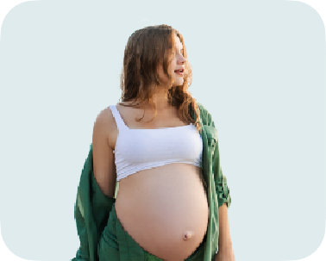
- Get pregnant when they are younger than 18.

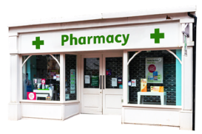
Pharmacies in Milton Keynes

42

There are 42 pharmacies in Milton Keynes.


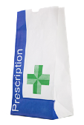
2 doctor's surgeries in Milton Keynes have a pharmacy.
2

Milton Keynes has nearly 15 pharmacies for every 100,000 people.

15 per 100,000

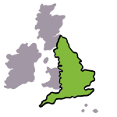
This is not as many as the rest of England.

Less

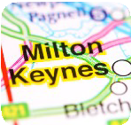
Some parts of Milton Keynes have more pharmacies than others.

More


8 in 10 people could walk to a pharmacy in less than 15 minutes.
15 minutes


Most people could drive to a pharmacy in less than 5 minutes.
5 minutes

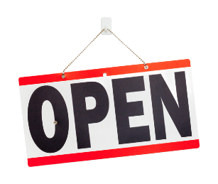
31 pharmacies in Milton Keynes are open on Saturdays, and 8 are open on Sundays.


We found out that there are lots of different pharmacy services in Milton Keynes which meet people's health needs.

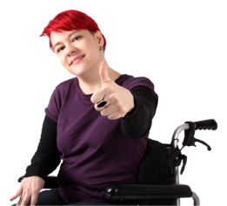
People are able to get to and use these services.

Pharmacy services in Milton Keynes
There are lots of services you can get at pharmacies in Milton Keynes, like:

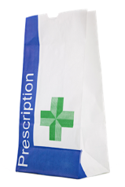
Giving you medicines your doctor
•

prescribes.
Prescribe means to give you a note for medicines you need.


- Recommending and selling you other medicines.

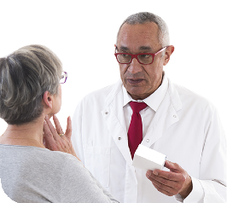
- Giving you advice about staying healthy.

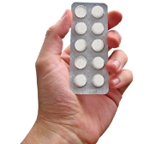
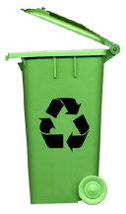
- Safely throwing away your old or unwanted medicines.


Pharmacies in Milton Keynes can also:

- Help you go to the right health services.

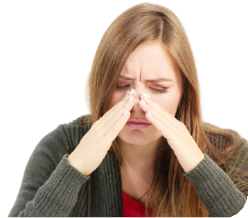
- Help you with common illnesses that are not serious.

Some pharmacies also provide:

- Extra help for people who have long-term conditions.

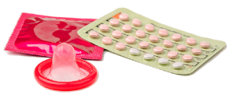
Help with emergency
•

contraception.
Contraception is medicine to stop pregnancy.

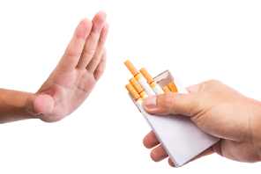
Some pharmacies also provide:

- Help with stopping smoking.

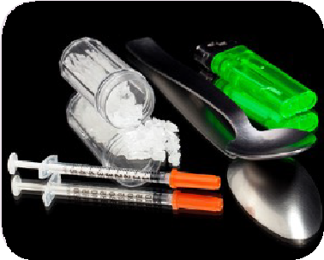
- Help for people who are addicted to drugs.

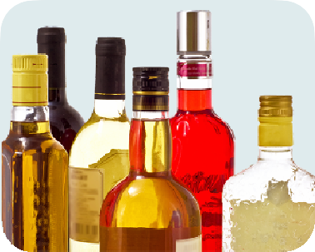
- Help for people who drink too much alcohol.

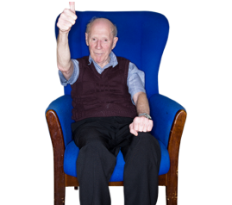
- Help making people feel comfortable at the end of their lives.


What people told us


We asked people questions about pharmacies in Milton Keynes to find out what they think of them.

466 people

466 people answered these questions.


Most people have a pharmacy they prefer to go to.

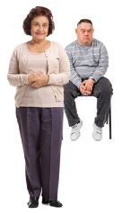
Most people visit the pharmacy for themselves, but a lot also visit pharmacies for family members.

Most people use their pharmacy to collect prescribed medicines.
Prescribed medicines are medicines a doctor has given you a note for.

People also use their pharmacy to:

- Buy other medicines. Some of these are recommended by a pharmacist
or pharmacy staff.

- Get advice about staying healthy.

- Throw away their old or unwanted medicines safely.


3 out of every 5 people travel by car to their pharmacy.

3 out of 5


3 out of every 10 people walk to their pharmacy.

3 out of 10

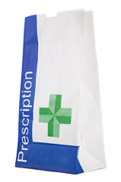
Most people use their pharmacy between 9am and 5pm on Monday to Friday.

9am to 5pm Monday to Friday

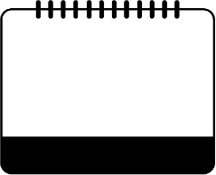
About 1 in 4 people use their pharmacy on a Saturday morning.

Saturday morning
1 in 4

Not as many people use their pharmacy on Sundays.
Sunday
Less

Ways pharmacy services can be better
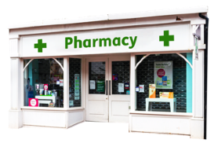

Generally, pharmacies in Milton Keynes meet the needs of the people in Milton Keynes.

We will carry on looking at:
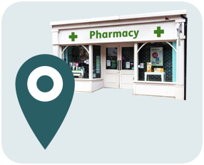

- Where pharmacies are.

- When pharmacies are open.


- What services pharmacies provide.

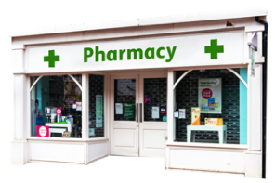
We will try to encourage all pharmacies to provide all the services.


We will look at ways to help pharmacies make it easier for people who do not speak English to use pharmacy services.

This Easy Read booklet was produced by easy-read-online.co.uk
The booklet includes images licensed from Photosymbols & Shutterstock.

