Oral Health Needs Assessment of Children and Young People in Milton Keynes (May 24)

Table of Contents
Executive Summary 4
Aims and objectives of this health needs assessment 5
Introduction 6
Background 6
Causes of dental decay 6
Statutory duty 8
Government Strategies 8
Local context 9
Local population 9
Local dentists 9
Community Dental Services 11
Oral health data 12
Methodology 12
Local data 14
Dental decay in three-year-olds 14
Dental decay in five-year-olds 16
Variation in dental decay by deprivation 19
Tooth extractions 19
Attendance at NHS dental practices 21
Regional and national data 23
Current services 26
Effectiveness of interventions for prevention of poor oral health 27
Community-based oral health improvement programmes and interventions 27
Interventions for people with Special educational needs and disabilities (SEND) 28
Water fluoridation: 29
Cost-effectiveness of interventions 29
NICE recommendations for oral health 30
Views of stakeholders, parents, and carers 31
Views of stakeholders 31
The views of parents and carers 33
Conclusions 34
Recommendations 36
Appendices 37
References 38

Executive Summary

Oral health of children
- There is limited data available on dental decay in three-year-olds in Milton Keynes. In 2020, prevalence of dental decay among three-year-olds was 7.6%, statistically similar to the English average of 11%.
- In 2022, 17.8% of five-year-olds had dental decay, statistically significantly lower than the England average of 23.7%. Among those with dental decay, the average number of affected teeth was 3.3.
- The rate of tooth extractions in hospital for children in Milton Keynes is lower than the English average, though it is not clear what is contributing to this. NHS England Core20PLUS5 for children and young people identifies addressing the backlog for tooth extractions in hospital for the under 10s as one of its five focus clinical areas.
- Local prevalence of dental decay in five-year-olds varies by ethnicity, with highest levels seen in children of ‘other ethnic background’ and Asian/Asian British children. Of children who have experienced decay, children of ‘other ethnic background’ and Asian/Asian British children also have the highest number of decayed, missing, or filled teeth.
- National data show a strong relationship between dental decay and deprivation, illustrating clear inequalities in oral health. Data also show that that tooth extractions for dental decay are nearly three and a half times higher in children living in the most deprived communities, compared to those in the least deprived.
- National data highlights that amongst children attending special schools, while overall prevalence of dental decay was lower than in mainstream educated children, those children who have experience of decay tend to have more teeth affected.
- National evidence suggests that children with excess weight are more likely to have dental decay than those with a healthy weight, indicating that excess weight in children may be an indicator for dental decay.

Evidence based oral health interventions
- Daily supervised brushing programmes including provision of fluoride toothpaste have been shown to be associated with significant reduction in dental caries in five-year-olds, with larger reductions in the most deprived communities – suggesting that the programme may be effective at reducing inequalities in oral health in this age group. Supervised use of fluoride mouthwash was also associated with reductions in dental decay in children.
- The application of fluoride gels (either by professionals, or self-applied) is associated with a 28% reduction in dental decay in permanent teeth in children, compared to controls.
- Water fluoridation is an effective public health intervention for both reducing prevalence of dental decay, and reducing oral health inequalities. The power to introduce water fluoridation schemes lies with the Secretary of State for Health and Social Care.
- There is limited evidence available investigating the cost-effectiveness of oral health interventions. Analysis carried out in 2016 concluded that water fluoridation, targeted provision of toothbrushes and toothpaste by post or by health visitors, targeted supervised tooth brushing programmes, and targeted fluoride varnish programmes all showed positive return on investment.
Since 2019, there has been no discrete oral health improvement service in Milton Keynes. The oral health offer is embedded in policy and practice within other Public Health commissioned services (0-19 Healthy Child Programme contract and Children and Family Centres), and via resources promoted by the Local Authority Public Health team.

Views of stakeholders, parents and carers
- Staff working with children, young people, and families reported regularly giving oral health information to service users, of whom most (85%) felt confident giving oral health advice to service users. 28% of respondents reported having oral health training in the last five years.
- Information sharing activities in Children and Family Centres were identified as working well, as were discussions between Health Visitors and families at one- and two-year development reviews, and oral health promotion from School Nurses.
- A gap was highlighted in available information for parents of children and young people with special educational needs and disabilities (SEND), particularly related to coping with sensory challenges of toothbrushing. A gap was also reported in provision of information in multiple languages for families with English as an additional language, though specific languages were not suggested.
- Financial pressures were raised by multiple stakeholders, who reported that families were sometimes unable to prioritise spending money on new toothbrushes or toothpaste. Provision of free toothbrushing kits and brush exchange events were highlighted as interventions that worked well, including using them to encourage families to attend educational sessions and to talk about oral health.
- While parents and carers in focus groups were generally positive about having enough information and education about oral health, only 40% of parents and carers who responded to questionnaires reported feeling like they had enough information about looking after the dental heath of their child or children. When asked about where they would like to find information about children’s dental health, parents and carers identified nurseries, play groups, schools, GP practices.

Access to NHS Dental services
- NHS dental services are available in Milton Keynes, all of which are concentrated in the Milton Keynes urban area. For much of rural Milton Keynes, there are no NHS dental services within either a 20-minute walk or 30-minute public transport travel time.
- There are few dentists accepting new NHS patients. Of the 25 NHS dental services in Milton Keynes identified in this needs assessment, four were listed as accepting children aged 17 or under as new NHS patients at the time of analysis.
- Families reported differing levels of access to NHS dentists, for both parents and children. For families not able to access NHS dental services, the main issue reported was lack of local dentists accepting new NHS patients. Transport to dental services was highlighted as an issue, with families reporting a need for dental services within walking distance from home.

Recommendations
The recommendations below are based on the findings of this health needs assessment and focus on oral health improvement priorities within the remit of Local Authority Public Health, as set out in the Health and Social Care Act (2012).

Current oral health promotion offer
- Continue the provision existing oral health promotion activities through the 0-19 contract and Children and Family Centres.
- Embed systems to measure activity and impact of the current oral health promotion offer and undertake regular monitoring.
- Establish the level of need for increased oral health training for staff working with children, young people, and families.
- Relaunch the local Health & Wellbeing Awards for schools & settings

Oral health information for families
- Ensure oral health information resources are routinely available to families at locations including early years settings, primary schools, and GP practices.
- Ensure appropriate oral health information resources are available for parents and carers of children and young people with special educational needs and disabilities (SEND). These should include how to cope with sensory challenges when toothbrushing.
- Ensure culturally appropriate advice and information on oral health is available for families with babies and young children in groups at high risk of poor oral health. This may include, for example, providing oral health information in other languages.

Scoping additional service provision
- Scope provision of additional oral health improvement programmes in Milton Keynes, targeted towards children and young people at risk of poor oral health. This may include:

  - Considering additional access points to offer free tooth brushing packs to offer to families in groups at high risk of poor oral health. For example, 0-19 services. Distribution of packs should be combined with information on when and how to brush teeth, a practical demonstration and information about local dental services.
  - Commissioning supervised tooth brushing schemes for nurseries and primary schools in areas where children are at high risk of poor oral health, in line with NICE guidelines. These should include providing free toothbrushes and fluoride toothpaste.
  - Commissioning a community-based fluoride varnish programme for nurseries as part of early years services for children aged 3 years and older, in line with NICE guidelines. In particular, children and young people with SEND.

Making oral health a strategic priority
- Use the findings of this OHNA to inform the development of a system-wide alliance to improve the oral health of children and young people in Bedfordshire and Milton Keynes
- Include oral health as a component of future joint strategic needs assessments for Milton Keynes City Council.
- Consider the need for additional dental epi for children and young people with SEND.

Aims and objectives of this health needs assessment
The aim of this Oral Health Needs Assessment (OHNA) is to describe the oral health profile of children and young people living in Milton Keynes, to provide an overview of the currently commissioned oral health improvement services in the area, and to identify any potential gaps in service provision.
This needs assessment, in parallel with an OHNA for Bedfordshire, aims to inform the development of an action plan to improve the oral health of children and young people in Bedfordshire and Milton Keynes.
This needs assessment focuses on oral health improvement priorities within the remit of Local Authority Public Health, as set out in the Health and Social Care Act (2012). While dental health services (commissioned by NHS England), and water fluoridation (decisions about which lie with the Secretary of State for Health and Social Care) are discussed within this OHNA, they are beyond the scope of Local Authority service provision and are therefore not included in recommendations.
Objectives:
- To describe the demographic characteristics of the population
- To present prevalence of poor oral health of children and young people, and inequalities in experience of poor oral health
- To provide an overview of oral health promotion activities in the area
- To summarise stakeholder and family views of maintaining oral health
- To present evidence of effectiveness, and cost-effectiveness of oral health interventions for children and young people
- To provide recommendations to improve the oral health of children and young people and reduce the inequalities that exist in the local area

Introduction

Background
The World Health Organisation (WHO) defines oral health as “a state of being free from chronic mouth and facial pain, oral and throat cancer, oral infection and sores, periodontal (gum) disease, tooth decay, tooth loss, and other diseases and disorders that limit an individual’s capacity in biting, chewing, smiling, speaking, and psychosocial well-being”.
Oral health problems encompass many diseases and conditions. The range of oral diseases to which people are susceptible, and their personal risk factors, change across the life course, with children and young people being most likely to be affected by dental caries. Dental caries, also called dental decay, often starts without symptoms in early stages, but advanced stages may lead to pain, infections and abscesses, or even sepsis. Dental decay can be prevented by reducing the consumption of sugary foods and drinks (both the amount and frequency of consumption) and ensuring adequate fluoride exposure.
Poor oral health has a significant impact on quality of life, particularly for children and young people; pain and discomfort can affect children’s nutritional intake and consequently their general health and development. It can affect quality of sleep, school performance and attendance, and affects self-esteem.
In England, 1 in 4 children experience dental decay at the age of 5 years, and those children with experience of dental decay have on average between 3 and 4 affected teeth. Between 2007 and 2015, there was a clear trend of decreasing prevalence of dental decay in five-year-olds, but data have shown no further improvements in prevalence of decay from 2017 to 2022.
The distribution of experience of dental decay is inequitable, with children living in the most deprived areas of the country being 2.5 times as likely to experience decay as those living in the least deprived areas. Children in the most deprived areas are also more likely to have more severe levels of decay. Decay occurs more frequently among those with severe disabilities and medical problems, socially excluded and vulnerable groups, including looked after children. As with many other health problems, oral health inequalities are preventable.
Tooth decay is still the most common reason for hospital admission in children aged between 6 and 10 years. In the financial year 2021-22, the estimated costs to the NHS of hospital admissions for tooth extractions in children aged 0 to 19 years was £81.0 million for all tooth extractions and £50.9 million for caries-related tooth extractions. This is a significant increase compared with the costs in the previous financial year, likely due to a combination of recovery of services following the COVID-19 pandemic and increased NHS costs.
In 2019, national data showed that 6% of children aged 0-15 years took time off nursery or school because of problems with their teeth, with 4% and 3% of mothers and fathers, respectively, taking time off work because of problems with their child’s teeth.

Causes of dental decay
Everyone is at risk of dental caries, but children and adolescents are most at risk. Dental decay happens when a tooth’s surface is broken down (demineralised) by acid, which is produced when bacteria in the mouth break down sugar. This process happens over time and can be reversed in the early stages of the disease. When factors promoting demineralisation exceed those promoting remineralisation, dental caries progresses, and the tooth surface breaks down.

Two major behavioural factors contributing to likelihood of dental decay are therefore exposure to dietary free sugars, and exposure to fluoride (a remineralising agent) during at-home tooth brushing.²
A healthy diet is important for oral and general health. Two elements of a healthy diet include eating the right amount of food, and eating a range of different types of foods. Surveys show that in the UK, people eat too many ‘free sugars’, too much saturated fat and salt, and not enough fruit, vegetables, fibre and oily fish. The term ‘free sugars’ includes all sugars added to foods and drinks, as well as sugars naturally present in honey, syrups, smoothies, and fruit juices, or any sugars in drinks (except in milk). For children and young people, the main sources of free sugars include soft drinks, cereal products, preserves, and confectionary.
The amount and the frequency of sugar intake is important for dental decay. Each time sugars are eaten, bacteria in the mouth convert the sugar to acid (lowering the pH in the mouth), which causes demineralisation. It takes about 20 to 40 minutes for the pH to return to normal, when remineralisation can happen. When sugar intakes are more frequent, demineralisation occurs more often, and may mean that the pH in the mouth cannot return to normal for long enough for remineralisation to happen, as illustrated in Figure 1. Diets that prevent tooth decay minimise the amount and frequency of consumption of sugary foods and drinks, and avoid sugary foods and drinks at bedtime. For infants, breastfeeding in the first six months of life is associated with decreased risk of dental decay.
00
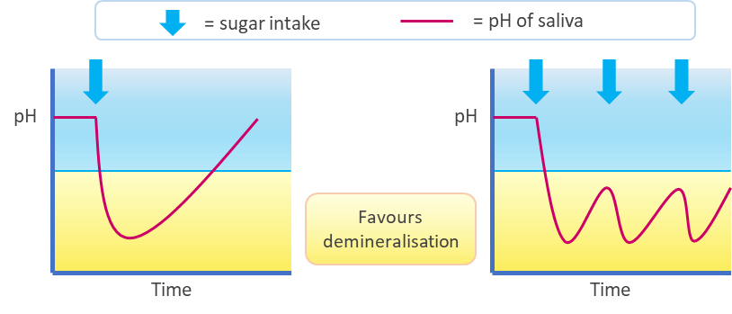
Figure 1: Stephan curve of pH in the oral cavity. The area coloured yellow represents conditions which favour demineralisation of tooth surfaces (low pH).
Reproduced from Office for Health Improvement and Disparities²

Effective toothbrushing with a fluoride toothpaste is important to support oral health. The physical action of brushing removes plaque, and the fluoride in toothpaste helps to remineralise teeth and prevent dental decay. Current advice is to brush teeth at least twice every day (at bedtime and on at least one other occasion), with fluoride toothpaste. Expert opinion suggests that children need to be helped with toothbrushing until at least seven years of age, after which many children can brush their own teeth but may require supervision, motivation, and possibly assistance. For infants, brushing should start as soon as they get their first primary tooth.
The 2019 Cochrane Review of fluoride toothpastes of different concentrations for preventing dental caries supports the benefits of using fluoride toothpaste in preventing caries when compared to non‐fluoride toothpaste.

While toothpaste is the most common source of fluoride exposure, there are many other ways of increasing exposure to fluoride. Some of these preventive interventions are discussed later in this need assessment under ‘effectiveness of interventions for prevention of poor oral health’.
Alcohol and tobacco use both negatively impact oral health, as well as having a significant impact on ill health and health inequalities. The majority of children and young people do not smoke tobacco, with national data from 2021 indicating that 3% of 15-year-old boys and girls in England were regular smokers. A higher proportion of young people drink alcohol, with 20% of 15-year-olds reporting that they had had an alcoholic drink in the last week.
More broadly, the determinants of health that create the social and physical conditions of people’s lives also affect risk of poor oral health. These include economic, welfare, employment, and education policies, which influence the resources and opportunities available to people, as well as day-to-day social and living circumstances of people, which affect access to resources, healthcare, and social relationships. Dental decay is associated with socioeconomic status, with high prevalence rates among the poor and disadvantaged population groups.⁸
Many risk factors for oral health are also risk factors for poor general health and therefore promoting oral health can also effectively help people to care for their general health. Improvements in oral health and a reduction in health inequalities requires this common risk factor approach, with a focus on tackling the structural and environmental determinants of chronic diseases.

Statutory duty
Local authorities are statutorily required to provide or commission oral health promotion programmes to improve the health of the local population, as set out in the Health and Social Care Act (2012). They must assess local oral health needs and commission evidence based oral health programmes appropriate to those needs. This includes work in early years settings, schools and training staff who work with children and young people.
They are also required to provide or commission oral health surveys. The oral health surveys are carried out as part of the national dental public health intelligence programme, which is outlined in more detail in the methodology section of this report.
Dentists are commissioned by NHS England to provide treatment.

Government Strategies
Government guidance on child oral health is found in the ‘Applying All Our Health’ report, published by the Office for Health Improvement and Disparities (OHID). It summarises evidence-based advice and treatment for health and care professionals; provides actionable strategies for healthcare managers and senior leaders and signposts to other resources, including Change4Life.
Core20PLUS5 is a national NHS England approach to support the reduction of health inequalities for children and young people at both national and system level. The approach defines a target population cohort and identifies five focus clinical areas requiring accelerated improvement, one of which is oral health (address the backlog for tooth extractions in hospital for the under 10s). The ‘Core20’ refers to the most deprived 20% of the national population as identified by the Index of Multiple Deprivation (IMD). The ‘PLUS’ population groups include ethnic minority communities, inclusion health groups, people with a learning disability and autistic people, amongst others. Special consideration should be taken for inclusion of young carers, children in care and care leavers, and those in contact with the justice system.
The Soft Drinks Industry Levy (SDIL) was introduced in 2016 to contribute to the government’s plans to reduce childhood obesity by removing added sugar from soft drinks. The levy encourages producers of soft drinks to reformulate their products to reduce the sugar content, and reduce portion sizes, both to encourage consumers of soft drinks to move to healthier choices. While not directly aimed towards improving oral health, this legislation addresses the levels of consumption of sugar-sweetened beverages – one of the proximal causes of dental decay in children and young people. Recent evidence has shown that there have been reductions in the number of hospital admissions for tooth extraction since the introduction of SDIL, with largest absolute reductions seen in children from areas of higher deprivation.

Local context

Local Population
Milton Keynes (MK) is a predominantly urban borough in the central South East region of England, which gained City status in 2022. According to Office for National Statistics 2021 mid-year estimates, there are 288,201 people in Milton Keynes, of whom 72,904 (25%) are aged 18 years or younger . Between the last two censuses (held in 2011 and 2021), the population of Milton Keynes increased by 15.4%, higher than the overall increase for England (6.6%); the population of children aged under 15 years in Milton Keynes increased by 12.3% in this period.
Almost one in five (19%) children aged under 16 are living in relative low income. Eight of the 152 Lower Super Output Areas (LSOAs) in Milton Keynes are among the 10% most deprived areas nationally based on the Index of Multiple Deprivation (IMD); a further ten LSOAs are among the 10-20% most deprived, and ten among the 20-30% most deprived.
In 2021, 28% of the Milton Keynes population were from Asian, Black, mixed and ‘other’ ethnic groups, higher than the England and Wales average of 18%. In those aged 19 years or younger, 40% of people in Milton Keynes were from Asian, Black, mixed, or ’other’ ethnic groups, higher than the England and Wales average of 26%.

Local dentists
There are different sources of data available to show the number of dental services in an area. Dental services include dental practices that only provide specialist services (such as orthodontics), providers of private treatment only, practices that offer both private and NHS dental appointments, as well as those who provide urgent care. This health needs assessment has used a combination of available sources to present an up-to-date picture of the dental services in Milton Keynes, which together are presented below,. Data collation and analysis were carried out in November 2023. It is recognised that availability of NHS dental services is dynamic and the summary presented below may not represent availability at time of publication.
There are 25 locations of NHS dental services in Milton Keynes (Figure 2), all of which are concentrated in the Milton Keynes urban area. Mapping of transport times around dental services shows that for the majority of rural Milton Keynes, there are no dental services accessible within a 30-minute travel time using public transport - presenting a possible barrier to access for some rural communities. Many areas within urban Milton Keynes, in addition to all of rural Milton Keynes, fall beyond a 20-minute walk of the nearest dental service (approximately 1 mile, an estimate of the extent of ‘walking neighbourhood’). Maps of travel time around dental services are illustrated in Appendix 1.
Registration for dental services is not bound by catchment areas in the same way that access to many public services is. This allows patients to choose a surgery that is conveniently located for them, for example choosing a surgery near where they work or study, rather than close to where they live. However, dental surgeries may not always have the capacity to take on new NHS patients, in which case a patient may have to join a waiting list, look for a different dentist who is taking on new NHS patients, or be seen privately.
Of the 25 services in Milton Keynes, four dental surgeries were accepting children aged 17 or under as new NHS patients. All other NHS practices in the area were either not accepting new patients, or only taking NHS patients who were referred by another dentist. One surgery had no recent information on whether they were accepting NHS patients.
00

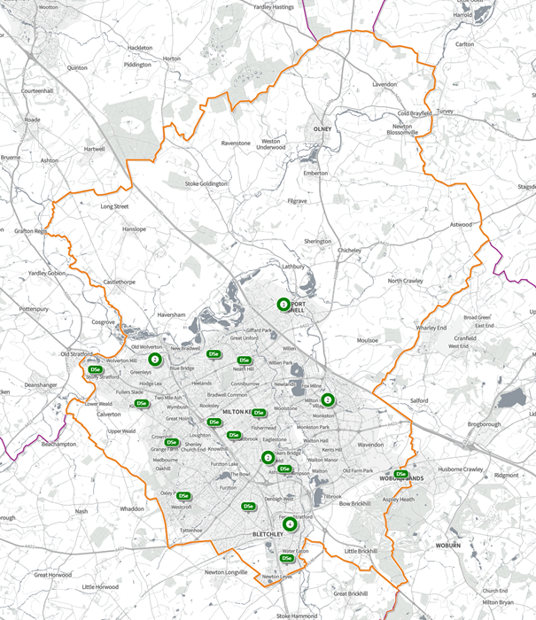
Figure 2: Distribution of dental services in Milton Keynes.
Each dental service is represented by a marker labelled DSe. Where there are multiple services in similar locations, a circle is shown, labelled with the corresponding number of services at that location. The orange boundary shows the extent of Milton Keynes City Council area.
Local data for adults show that people report difficulty accessing NHS dental care. In the two years to March 2023, only three quarters (74%) of adults in Bedfordshire, Luton and Milton Keynes (BLMK) who tried to get an NHS dental appointment in the last two years were successful. Respondents who had not been to the practice before were much less successful in getting an NHS dental appointment than returning patients. People from minority ethnic groups reported lower success rates (78% in White respondents, and 63% in respondents of all other ethnicities grouped).
It is important to note that not everyone chooses to access NHS dentists. Of adults in BLMK who had not tried to get an NHS dental appointment in the last 2 years, 23% preferred private dentistry, 23% did not identify a need to visit a dentist, 22% didn’t think they could get an NHS dentist, 7% found NHS dental care too expensive, 7% didn’t like going to the dentist, and 3% were on a waiting list for an NHS dentist.

Community Dental Services
Thames Valley Community Dental Services is a Partnership which provides Community Dental Services across Thames Valley. These services are commissioned by the NHS and provide specialist dental care for people who are unable to receive care from a general dental practitioner (GDP), but do not necessarily need to be seen in a hospital. Among children and young people this includes:
- Children with physical or learning disabilities
- Children with complex medical conditions
- Children with severe mental health problems
- Children with severe behavioural management problems
- Children with extensive untreated dental decay who are particularly anxious, or pre-cooperative
Children and young people can be referred to the community dental service by other dentists, health and social care professional, educational settings, and self-referral. The Community Dental Service operates from the Buckinghamshire Priority Dental Service (BPDS) at Eaglestone Health Centre in Milton Keynes and Shipley Court Dental Clinic in Newport Pagnell,.

Oral health data

Methodology

Oral health surveys
Oral health in five-year-olds has been measured by the National Dental Epidemiology Programme (NDEP) for England oral health surveys since 2007. Oral health surveys of three-year-old and five-year-old children are coordinated by OHID as part of the NDEP, though responsibility for commissioning the surveys lies with upper-tier local authorities.
Survey data for five-year-old children is available at local authority level for the years 2015, 2017, 2019, and 2022, with the next survey due in 2024. Survey data for three-year-olds is available for 2013 and 2020. The NDEP also conducted an oral health survey of children attending special support schools in 2014. Due to small numbers of children participating in this survey, findings are presented below for England overall.

Hospital extractions
OHID publishes annual official statistics on tooth extractions in 0- to 19-year-olds that take place in an NHS hospital setting in England. This data comes from the Hospital Episode Statistics dataset held by NHS Digital, and are calculated from the number of finished consultant episodes (FCEs) where a tooth extraction procedure was performed in an acute hospital care setting. This data is published annually and the most recent data available at the time of writing this report was for the financial year 2021-22.
This data don’t include extractions carried out at NHS dental practices, or at private clinics, therefore the data provided may underestimate the number of extractions for dental decay.

Attendance and treatment at NHS dental practices
Information on the number of children attending NHS dental practices in the local area is available from NHS Dental Statistics for England. This data is available quarterly, with each release summarising the previous 12-month period; the most recent data available at the time of writing this report was for the 12 months to 30th June 2023. This data does not include children who attend private dental practices.
Data is also available describing the type of treatment given to children and young people in NHS dental practices. NHS dental treatment is categorised into bands 1, 2, and 3. This reflects the charges attached to different treatment, although children’s NHS dental treatment is free at the point of access. Routine clinical examinations fall within band 1 treatment, as do X-rays, scale and polish treatments, and fluoride polish. Band 2 dental treatment incorporates additional treatment such as fillings, root canal treatment, and extractions. Band 3 treatment incorporates the most complex procedures such as bridges, crowns and orthodontic treatment like braces.
Together, these three data sources help to describe the oral health of children and young people in Milton Keynes, though do not explain it fully. Only some of the children and young people experiencing poor oral health or dental decay are aware of it, and a smaller section of that group seek advice and are known to dental services, as demonstrated in the diagram in Figure 3.
The data included in this needs assessment help to describe different sections of the triangle. Oral health survey data helps to quantify the proportion of children who are experiencing decay (i.e. in the top three levels combined), though cannot tell us whether the children were aware of their decay experience or had sought treatment or advice.
Hospital extractions data tell us about some of the cases at the top of the triangle, though children who have had hospital extractions represent only a proportion of the children and young people known to dental services. The number of hospital extractions may be influenced by many factors other than the normative need of the population, including capacity of services, waiting lists, availability of extractions in settings other than hospitals.
Dental attendance data help to tell us the coverage of access to services, however, given that all children and young people are recommended to attend regular dental check-ups, it covers children from all levels of the triangle. Treatment band data help to indicate the level of need of attendees, however, because not all children and young people are accessing services, this is unlikely to be representative of need in the population as a whole.

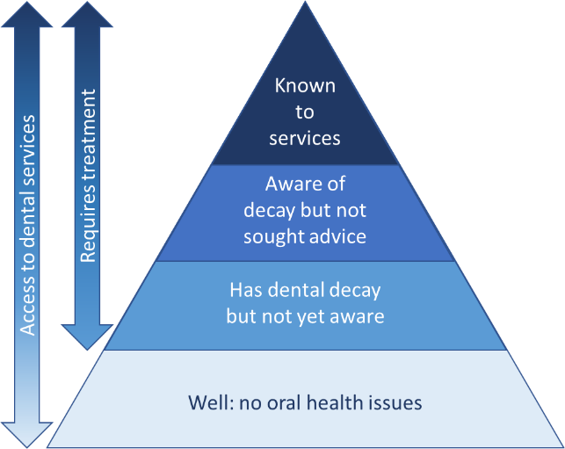
00
Figure 3: Levels of dental service need and use among a population

Statistical neighbour comparisons
Statistical neighbours have been used to facilitate benchmarking between Milton Keynes and other similar local authorities. Statistical neighbours are other Local Authorities deemed to have similar characteristics to Milton Keynes. The statistical neighbours were originally identified by the National Foundation for Educational Research (NFER), which was commissioned in 2007 by the Department for Education to identify and group similar authorities in terms of the socio-economic characteristics. The model has since been amended and statistical neighbours used in this needs assessment are taken from the 2021 update to the Children's Services Statistical Neighbour Benchmarking Tool (CSSNBT).

Local data
The following section covers the oral health of five-year-olds and three-year-olds in Milton Keynes, as well as hospital extractions for dental decay and attendance at NHS dental practices for children and young people up to 18 years old.
The oral health survey of five-year-olds in 2022 showed that almost one in five children in Milton Keynes have dental decay, lower than the England average. Each child with dental decay had, on average, 3.3 affected teeth. Dental decay starts early. The survey of three-year-olds in 2020 found that 8% of children in Milton Keynes had visible dental decay, though sample sizes for this survey were small and confidence intervals are therefore very wide. Oral health varied by deprivation and ethnicity; five-year-olds in more deprived areas had a higher prevalence of dental decay, as did those of Asian/Asian British or ‘Other’ ethnic groups.
The percentage of children and young people (0-18) seen by NHS dentists in the last 12 months of 2019 was 60%, higher than English average.

Dental decay in three-year-olds
The Oral Health Survey of 3-year-old children was carried out for small numbers of children in Milton Keynes in 2020, with prevalence estimates being produced based on examination of only 48 out of a population of almost 4,000 three-year-olds. Some prevalence estimates are therefore not available for this geography, and those that are available have wide confidence intervals and must be interpreted with caution.
In Milton Keynes, the prevalence of dental decay among three-year-olds in 2020 was 7.6%. Though this is statistically similar to the English average of 11%, it ranks prevalence in Milton Keynes second-lowest among its statistical neighbours.
Three-year-olds in Milton Keynes had, on average, 0.1 teeth with dental decay in 2020, which is statistically significantly lower than the English average of 0.3 teeth. This ranks Milton Keynes second-lowest among its statistical neighbours. The majority of experience of dental decay in this age group was obvious, untreated decay; none of the 48 children examined had filled teeth.
There were insufficient numbers of volunteers to calculate the prevalence of teeth affected by dental decay among those who have decay experience in Milton Keynes in 2020. National data show that as the majority of three-year-old children do not have experience of dental decay, the mean number of teeth with experience of decay in all children examined is low (0.3 teeth). The mean number of affected teeth in only those children who have experience of dental decay in England was 2.9 in 2020.
Data for Milton Keynes from 2013 show that among three-year-old children who have at least one tooth affected by dental decay, the average number of affected teeth was 3.2, statistically similar to the national average of 3.1 affected teeth.
There is limited data on the change in oral health of three-year-olds over time. Data were available for 2013 and 2020 only, and confidence intervals for these estimates are wide, restricting the identification of trends. The prevalence of dental decay among three-year-olds decreased in East of England and England overall decreased between 2013 and 2020. In Milton Keynes, prevalence in 2020 (7.6%) was statistically similar to prevalence in 2013 (7.8%).
The average number of teeth affected by dental decay among three-year-olds in Milton Keynes was 0.2 in 2013 and 0.1 in 2020, which was similar to the English average.

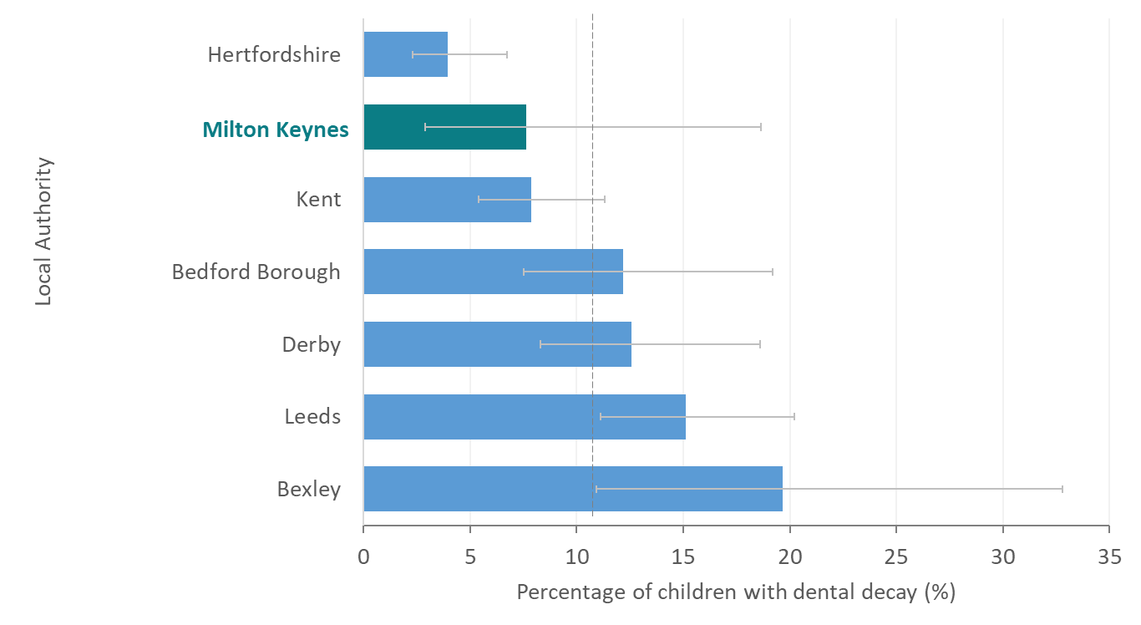
00
Figure 4: Percentage of three-year-olds with one or more decayed, missing, or filled teeth in Milton Keynes and statistical neighbours. Dashed line represents England value. Eror bars represent 95% confidence intervals. Source: Office for Health Improvement and Disparities, Oral health survey of three-year-old children 2020.
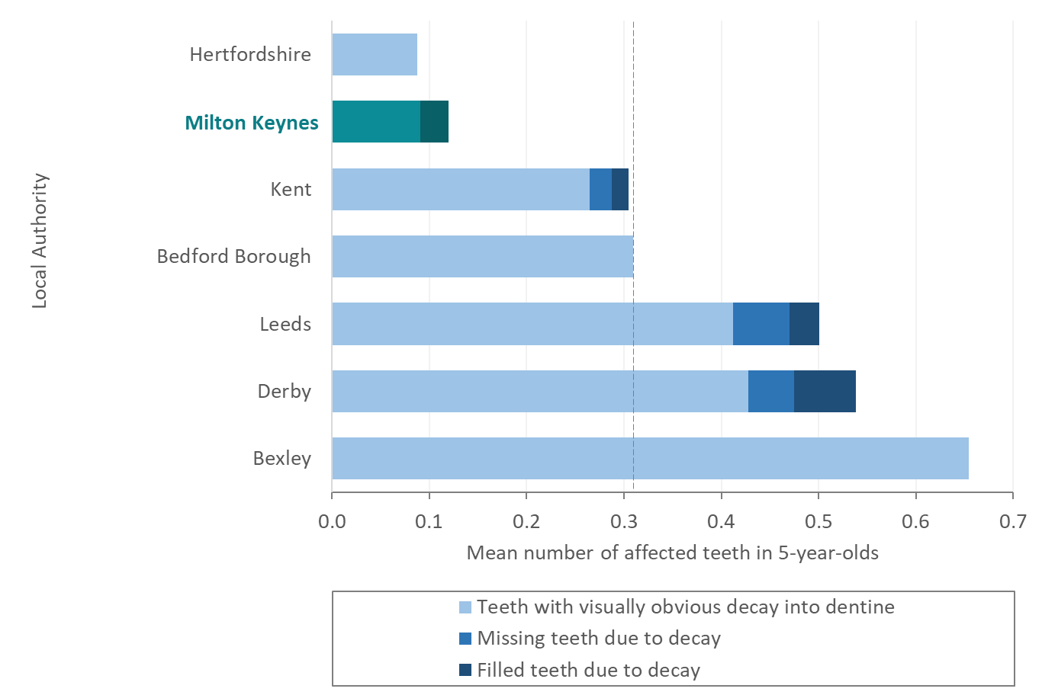
Figure 5: Mean number of decayed, missing, or filled teeth in three-year-olds in Milton Keynes relative to statistical neighbours. Dashed line represents England value.
Source: Office for Health Improvement and Disparities, Oral health survey of 3-year-old children 2020.

Note: No data for Reading, Thurrock, or Swindon Local Authorities.
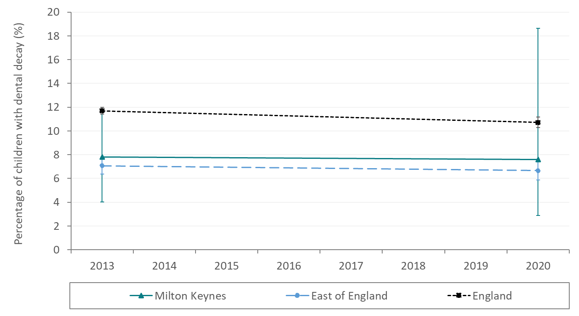
Figure 6: Time trend of the percentage of three-year-olds with one or more decayed, missing, or filled teeth Milton Keynes, East of England, and England. Error bars represent 95% confidence intervals.
Source: Office for Health Improvement and Disparities, Oral health survey of 3-year-old children.

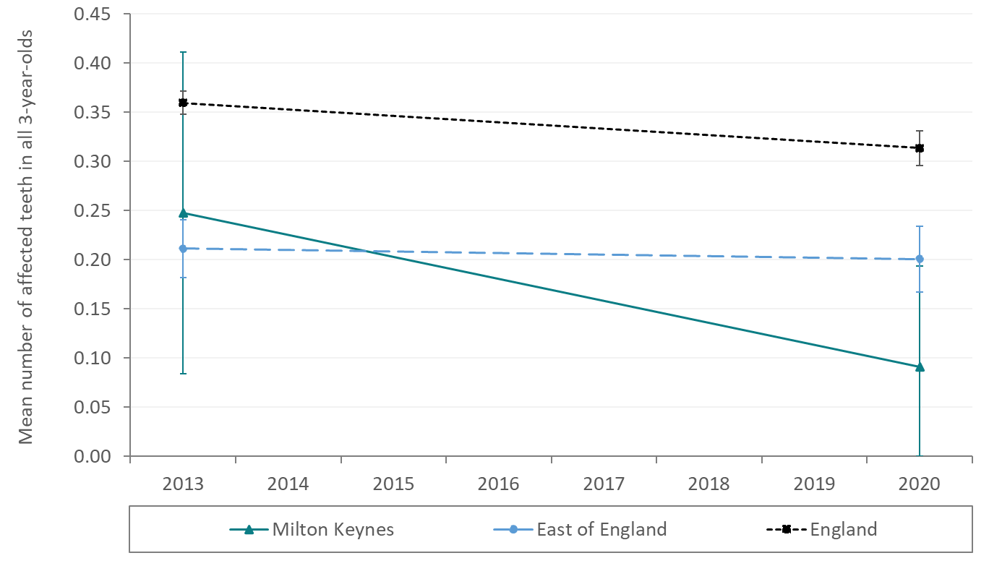
Figure 7: Time trend of the mean number of decayed, missing, or filled teeth in all three-year-old children in Milton Keynes, East of England, and England.
Source: Office for Health Improvement and Disparities, Oral health survey of 3-year-old children.
Note: Error bars represent 95% confidence intervals.

Dental decay in five-year-olds
In 2022, the percentage of five-year-olds with dental decay in Milton Keynes was 17.8%, which is the third-lowest value of its statistical neighbours, and statistically significantly lower than the England average of 23.7%.
On average, five-year-olds in Milton Keynes in 2022 had 0.6 teeth with dental decay, below the England average of 0.8. The majority of experience of dental decay in this age group was obvious, untreated decay.
Among five-year-old children in Milton Keynes who have at least one tooth affected by dental decay, the average number of affected teeth was 3.3. This is statistically similar to the national average of 3.5 affected teeth, and ranks Milton Keynes among the middle of its group of statistical neighbours.
In Milton Keynes, the prevalence of dental decay in five-year-olds has decreased over time from 21.5% in 2015 to 17.8% in 2022, though the difference is not statistically significant due to wide confidence intervals around prevalence estimates. Over the same period, prevalence estimates in the East of England region and England overall have remained relatively stable.
In Milton Keynes, the average number of teeth affected by dental decay in all five-year-olds has not changed significantly between 2015 (mean 0.6 teeth) and 2022 (mean 0.6 teeth). During this period, prevalence has remained statistically similar to the East of England average.
The average number of affected teeth in five-year-olds with at least one tooth affected by dental decay in Milton Keynes has not changed significantly between 2015 and 2022. The average has also remained stable in the East of England (3.4 affected teeth) and in England overall (3.4 affected teeth).

00
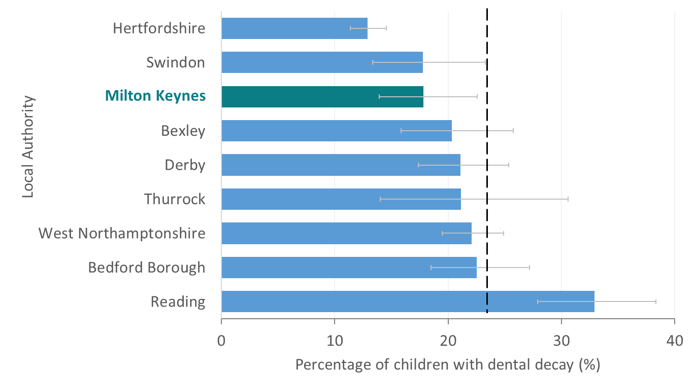
Figure 8: Percentage of five-year-olds with one or more decayed, missing, or filled teeth in Milton Keynes relative to statistical neighbours. Dashed line represents England value. Grey error bars represent 95% confidence intervals.
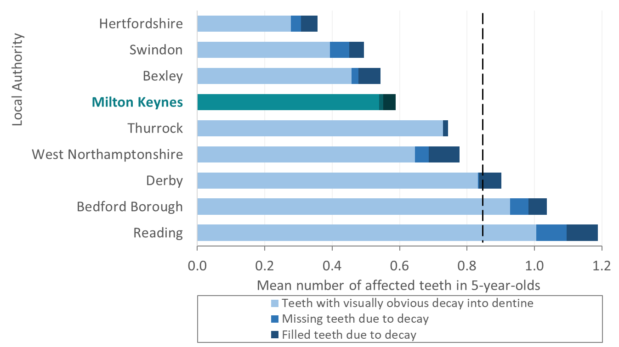
Figure 9: Mean number of decayed, missing, or filled teeth in five-year-olds in Milton Keynes relative to statistical neighbours. Dashed line represents England total.
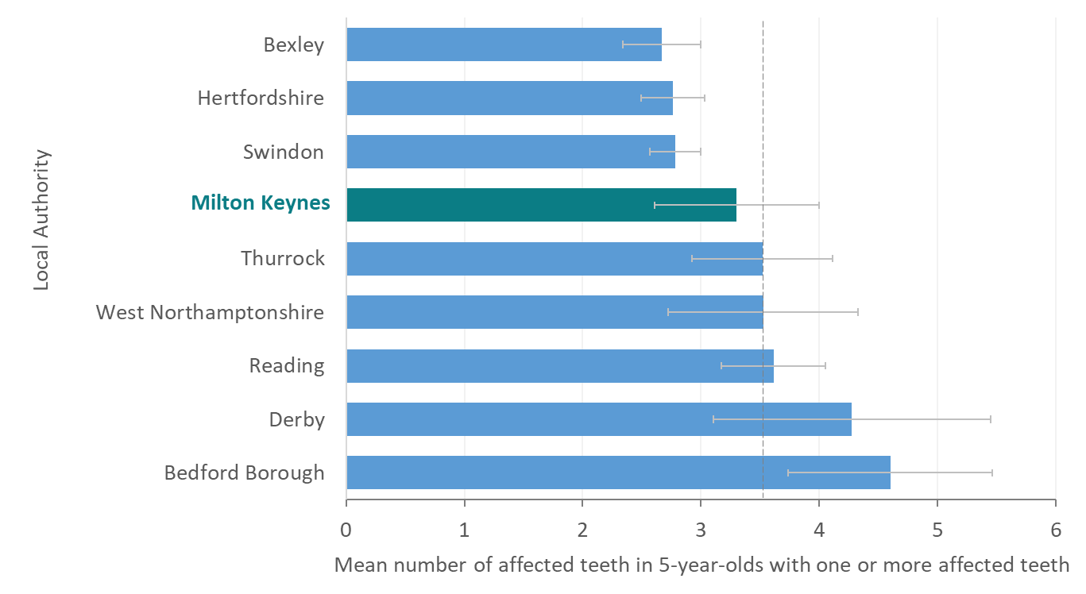
Figure 10: Mean number of decayed, missing, or filled teeth in five-year-olds who have at least one decayed, missing, or filled teeth in Milton Keynes relative to statistical neighbours. Grey line represents England value. Grey bars represent 95% confidence intervals.

Source: Office for Health Improvement and Disparities, Oral health survey of 5-year-old children 2022.
Note: No data for Kent or Leeds Local Authorities.
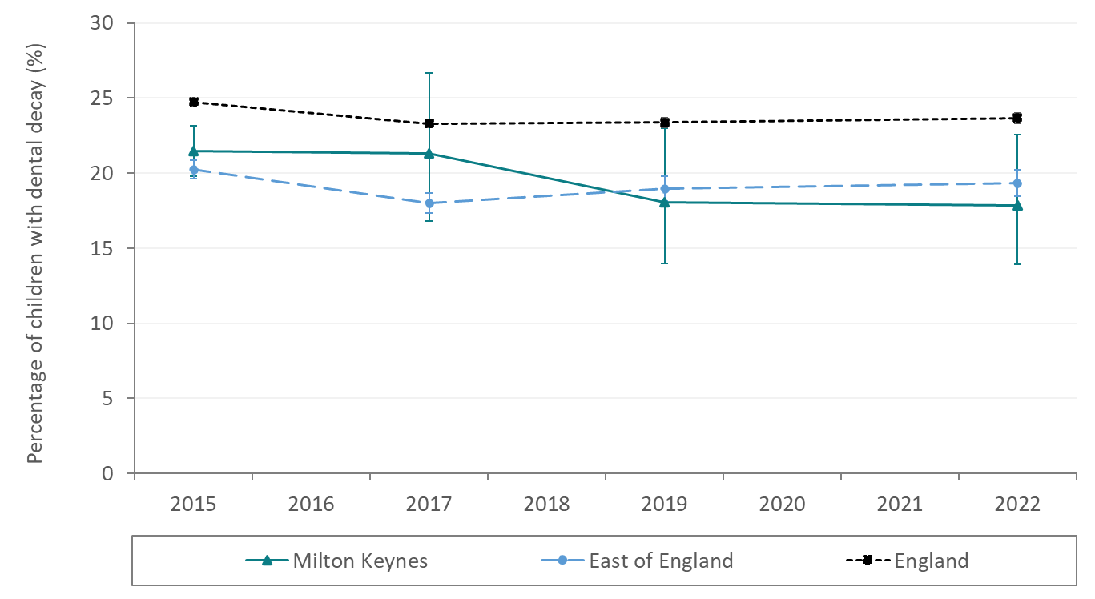
00
Figure 11: Time trend of the percentage of five-year-olds with one or more decayed, missing, or filled teeth in Milton Keynes, East of England, and England. Error bars represent 95% confidence intervals.
Source: Office for Health Improvement and Disparities, Oral health survey of 5-year-old children.
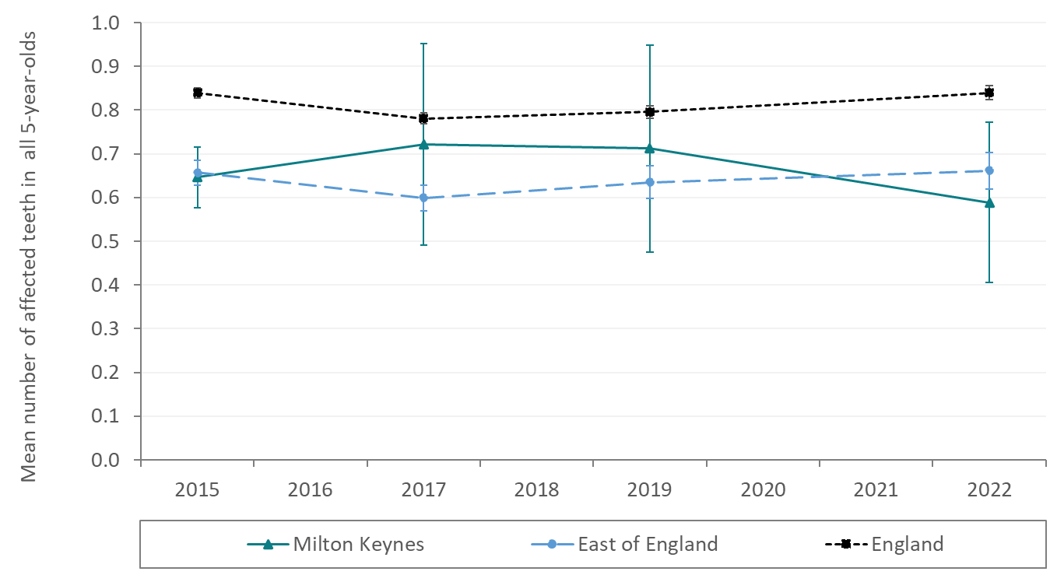
Figure 12: Time trend of the mean number of decayed, missing, or filled teeth in all five-year-old children in Milton Keynes, East of England, and England. Error bars represent 95% confidence intervals.
Source: Office for Health Improvement and Disparities, Oral health survey of 5-year-old children.
Note:
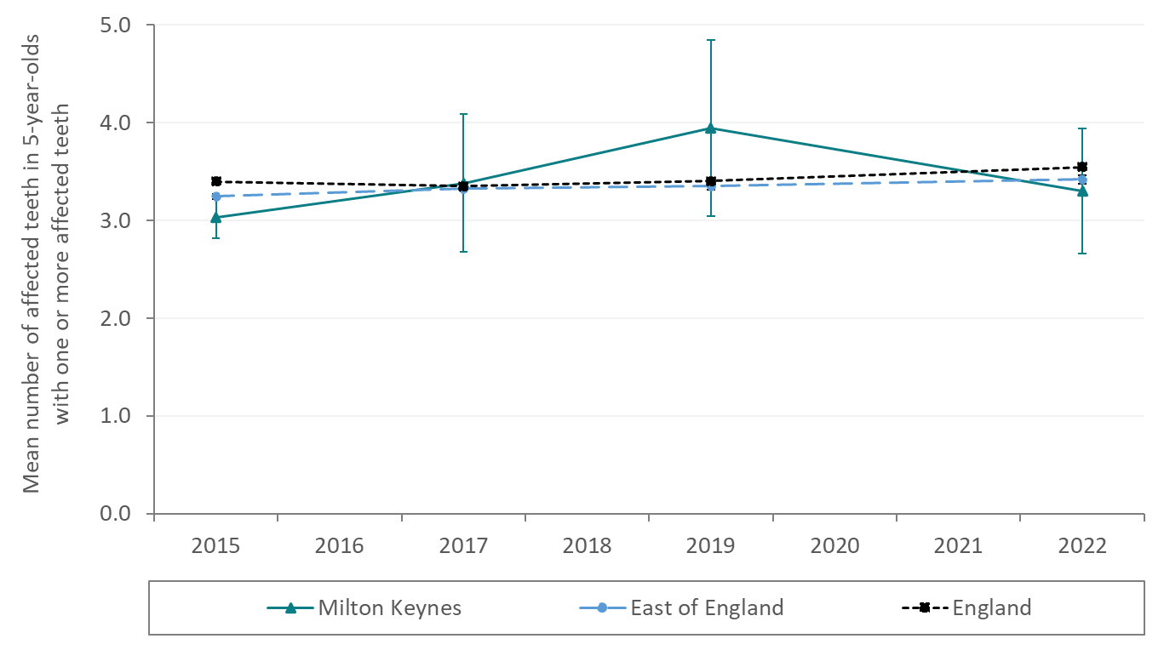
Figure 13: Time trend of the mean number of decayed, missing, or filled teeth in five-year-olds who have at least one decayed, missing, or filled tooth in Milton Keynes, East of England, and England. Error bars represent 95% confidence intervals
Source: Office for Health Improvement and Disparities, Oral health survey of 5-year-old children.

Variation in dental decay by deprivation
Oral health data by deprivation were not available for the 2022 survey at the time of writing this needs assessment.
In the 2019 survey, the prevalence of dental decay in five-year-olds in Milton Keynes varied by deprivation quintile (Figure 14). Children in the second most deprived quintile of the Index of Multiple Deprivation (IMD; a measure of deprivation) had the highest prevalence of dental decay. The lowest levels of dental decay were found in children from the least deprived quintiles.
Data for the South East region as a whole show a strong relationship between deprivation and dental decay in five-year-olds (see regional data). It is likely that a similar social gradient exists within Milton Keynes.
00
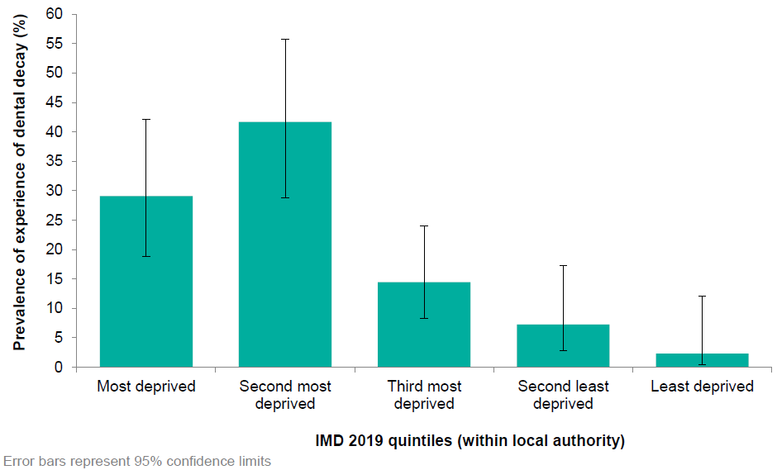
Figure 14: Percentage of five-year-olds with one or more decayed, missing, or filled teeth in Milton Keynes by IMD 2019 quintiles (within local authority).
Source: Dental Public Health Epidemiology Programme for England: oral health survey of five-year-old children 2019

Tooth extractions
In the year 2021-22, there were 80 finished consultant episodes for children and young people aged 0-19 for hospital tooth extractions in Milton Keynes. This is equivalent to a rate of 113 per 100,000 population, lower than the national average of 205 per 100,000 population and ranking among the middle of its statistical neighbours.
The number of hospital extractions reflects multiple factors, including oral health and dental access. Regular dental access allows for early intervention and decreases the need for hospital extractions. Having no access will also limit referrals for extractions, regardless of a child’s oral health. It is not clear from these data what is contributing the relatively low rates of hospital extractions among children and young people in Milton Keynes; further work is needed to understand the relationship between decay experience and extractions in greater detail.
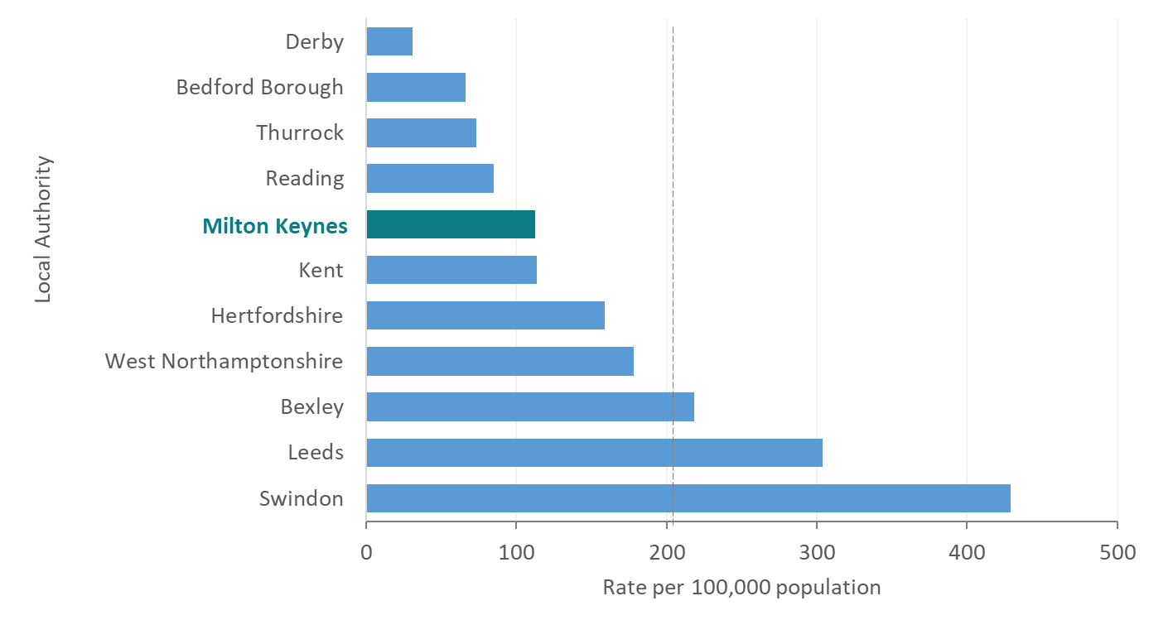
00
Figure 15: Finished consultant episodes for tooth extraction with caries as primary diagnosis in children and young people aged 0-19 in Milton Keynes and its statistical neighbours, rate per 100,000 population.
Source: Office for Health Improvement and Disparities, Hospital tooth extractions of 0 to 19 year olds 2021.
Note: Error bars represent 95% confidence intervals.

Nationally, the trend in rate of hospital extractions in 0-19 year olds appears to be decreasing, with a rate of 205 extractions per 100,000 population in 2021/22, down from 282 extractions per 100,000 in 2018/19. Rates of extractions in Milton Keynes appear to be decreasing in line with (but lower than) the national trend, with 113 extractions per 100,000 population in 2021/22, down from 210 extractions per 100,000 in 2018/19.
Extraction rates in the East of England remain broadly consistent from 2018/19 to 2021/22, with the exception of 2020/21. The reduced rates seen in 2020/21 are likely due to the impact of the COVID pandemic on non-COVID related hospital episodes, rather than sudden reduction in need or demand.
00
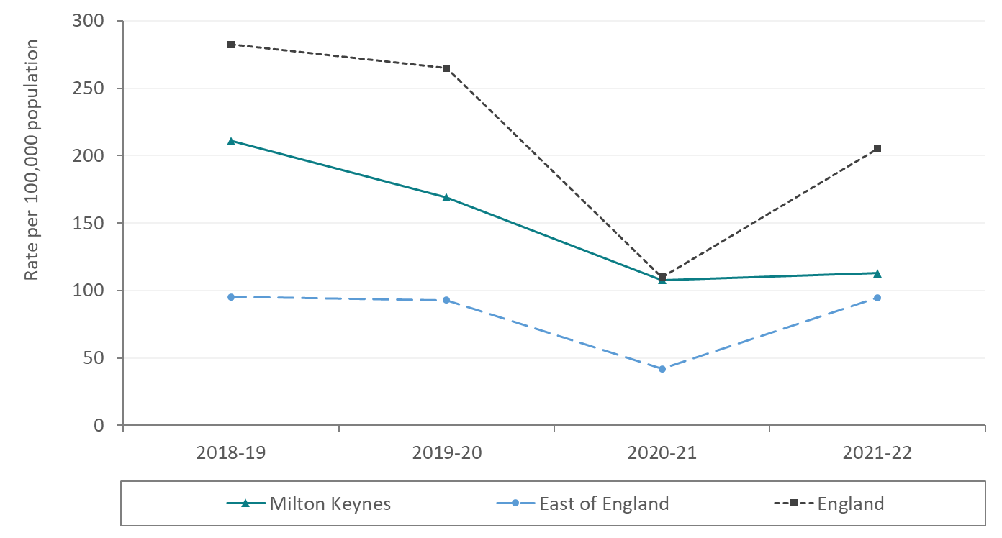
Figure 16: Trends in finished consultant episodes for tooth extraction with caries as primary diagnosis in children and young people aged 0-19 in Milton Keyes, East of England and England, rate per 100,000 population.
Source: Office for Health Improvement and Disparities, Hospital tooth extractions of 0 to 19 year olds 2021.

Attendance at NHS dental practices
In Milton Keynes, the percentage of children and young people (0-18) seen by NHS dentists in the 12 months to June 2023 was 60%. This was above the English average of 56% and ranked in the middle of its statistical neighbours.
00
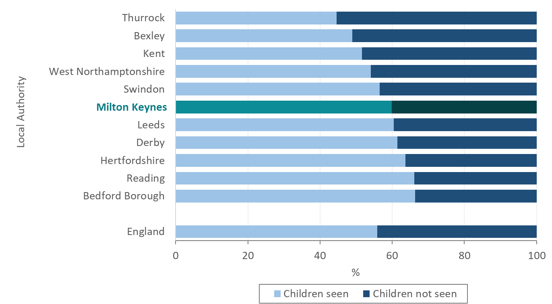
Figure 17: Percentage of children and young people aged 0-17 seen by NHS dentists in the 12 months to June 2023 in Milton Keynes and its statistical neighbours, and England.
Source: NHS Digital, NHS Dental Statistics for England, 2022-23, Annual Report

The proportion of children and young people seen by an NHS dentist in Milton Keynes in the previous 12 months has varied greatly over the past 5 years, though has remained above the England average. Attendance fell sharply during the covid-19 pandemic, reaching its lowest point in the 12 months up to 31st March 2021. Levels of access have recovered slowly since, though have not yet returned to levels seen before the pandemic.
00
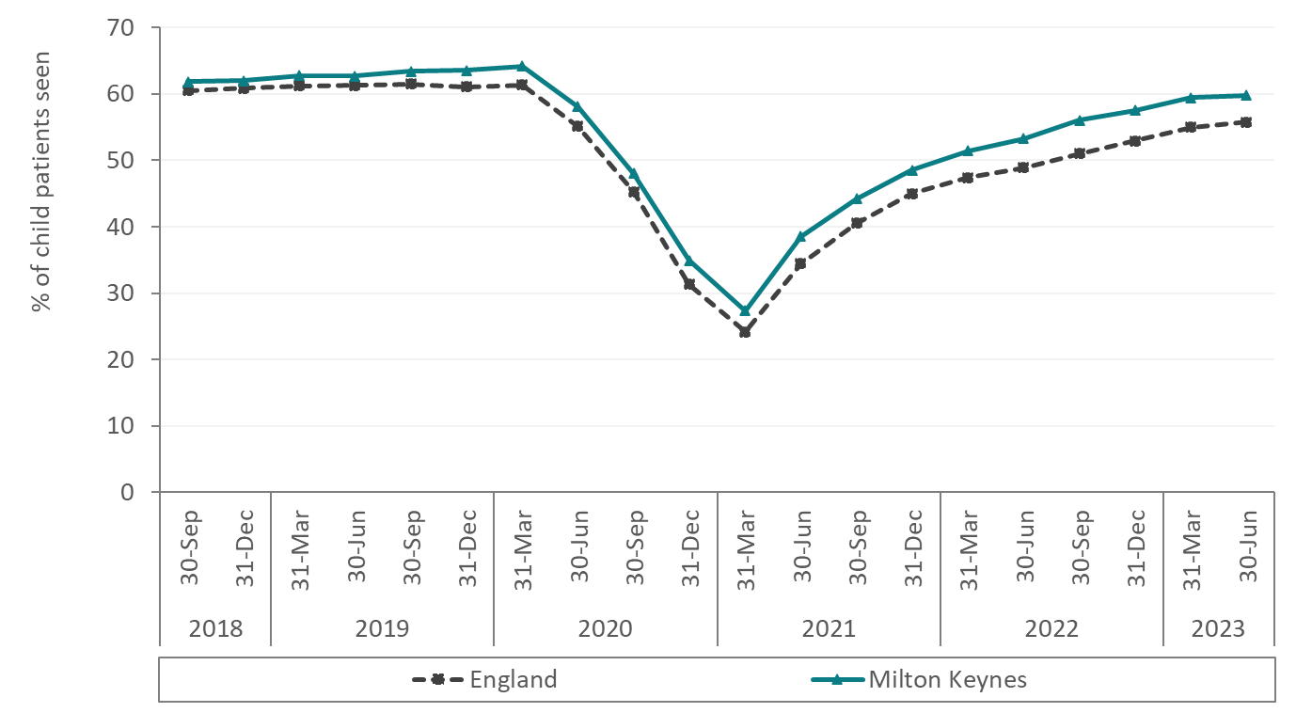
Figure 18: Percentage of children and young people aged 0-17 seen by NHS dentists in the previous 12 months (12-month rolling average) in Milton Keynes and England.
Source: NHS Digital, NHS Dental Statistics for England, 2022-23, Annual Report

The percentage of children and young people seen by NHS dentists in the 12 months to June 2023 varied by age. The lowest proportion was for children under 1, of whom 2% were seen; the proportion increased with age from early years up to a peak in those aged 15 years, of whom 86% were seen. The proportion of children and young people then decreased with age, with 67% of 17-year-olds being seen in the last year.
00
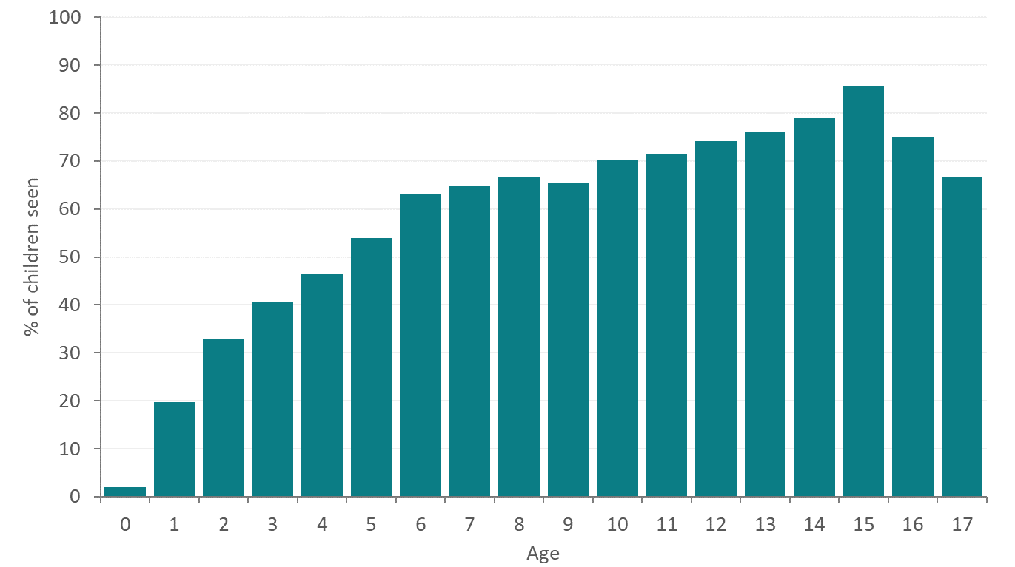
Figure 19: Percentage of children and young people aged 0-17 seen by NHS dentists in the 12 months to June 2023 in Milton Keynes by age.
Source: NHS Digital, NHS Dental Statistics for England, 2022-23, Annual Report

The majority of NHS treatment for children and young people (aged 0-18 years) in Milton Keynes was within Band 1 (77%), above the England average of 73% and highest of its statistical neighbours. In Milton Keynes, 22% of treatments were within band 2, and less than 1% were in band 3.
00
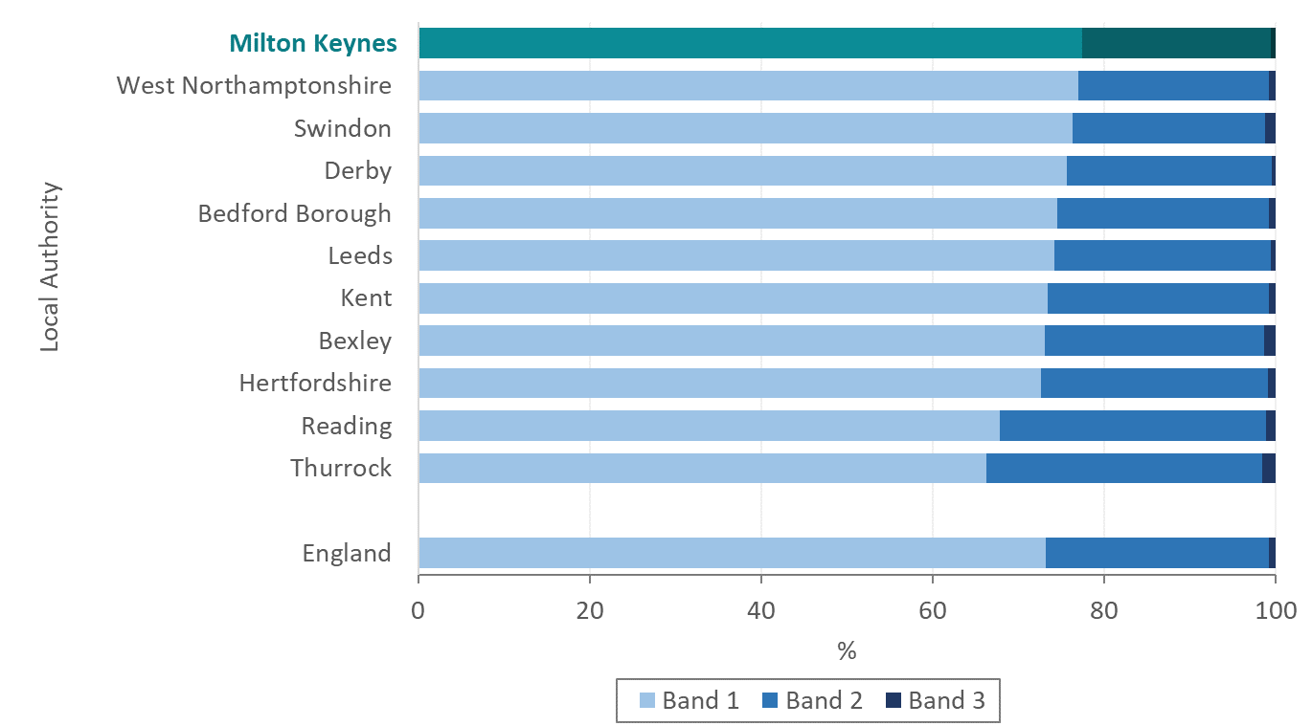
Figure 20: Proportion of NHS treatment for under 18-year-olds in treatment bands 1, 2, and 3 in the 12 months to June 2023 in Milton Keynes, its statistical neighbours, and England.
Source: NHS Digital, NHS Dental Statistics for England, 2022-23, Annual Report

Regional and national data
The following section discusses variation in oral health by ethnicity, deprivation, excess weight, and Special Educational Needs and Disabilities. These data were used where no local data were available.

Oral health and excess weight
National data from the National Dental Epidemiology Programme 2016/17, linked to individual height and weight data from the National Child Measurement Programme for the same year showed that children who are above a healthy weight were more likely to have dental caries, in all deprivation categories (Figure 21). Excess weight in children may therefore be an indicator of dental caries.
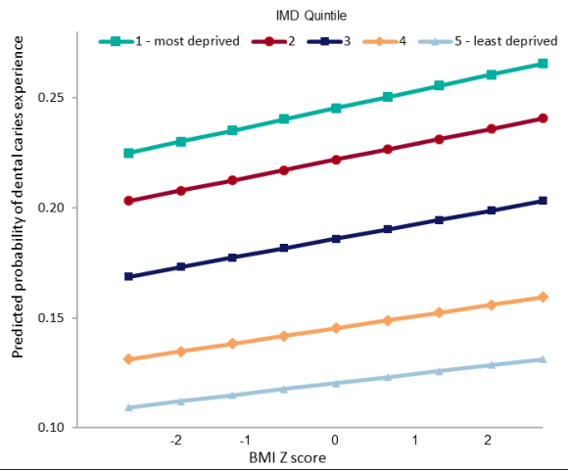
00
Figure 21: Caries prevalence by body mass index Z score and deprivation quintile, England, 2016/17
Source: Public Health England. Dental caries and obesity: their relationship in children

Variation in oral health by deprivation
Data from the 2019 oral health survey for the South East region as a whole demonstrate a strong relationship between dental decay in five-year-olds and relative deprivation, with a slope index of inequality of 16.6% (Figure 22). The SII is a measure of the social gradient in an indicator, and represents the range in values across the social gradient from most to least deprived.
00
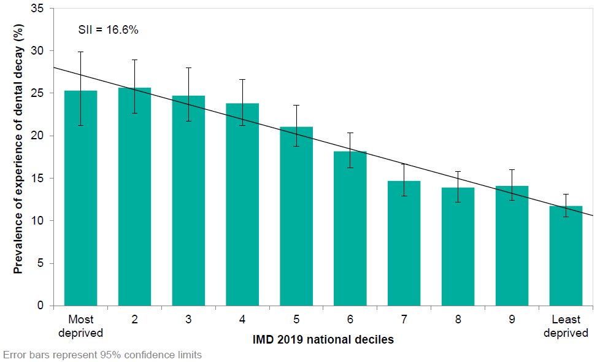
Figure 22: Percentage of five-year-olds with one or more decayed, missing, or filled teeth in South East region by IMD 2019 national deciles.
Source: Dental Public Health Epidemiology Programme for England: oral health survey of five-year-old children 2019.
SII = Slope index of inequality
National data show that the caries-related tooth extraction episode rate for children and young people living in the most deprived communities was nearly 3 and a half times that of those living in the most affluent communities (Figure 23).
00
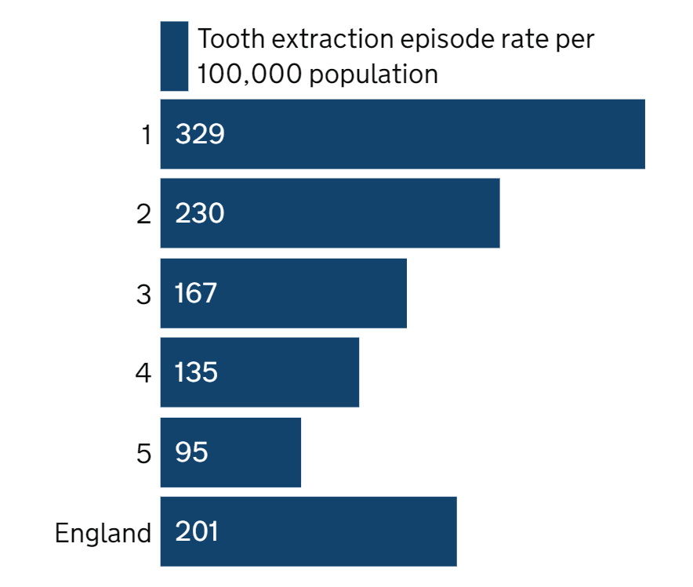
Figure 23: Caries-related tooth extraction episode rates per 100,000 population of 0- to 19-year-olds by IMD 2019 deprivation quintile population (1 is the most deprived quintile, 5 is the least deprived)
Source: Office for Health Improvement and Disparities. Hospital tooth extractions in 0- to 19-year-olds 2022.

Variation in oral health by ethnicity
The proportion of five-year-olds in the South East region with one or more teeth with dental decay was highest in children of ‘other ethnic background’ and Asian/Asian British children, with 39% and 34% (respectively) of children having decay experience. The lowest proportions were found in white children and children for whom ethnicity data were not provided, with between 15% and 17% of five-year-olds affected by dental decay in these groups.
00
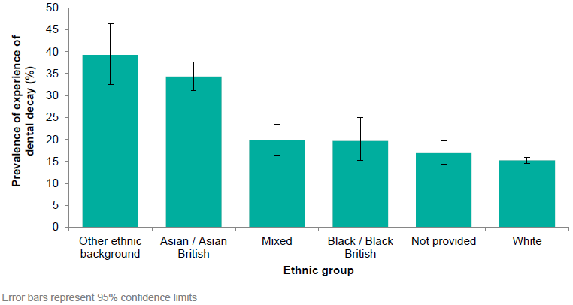
Figure 24: The percentage of five-year-olds with one or more decayed, missing, or filled teeth in the South East region by ethnic group.
Source: Dental Public Health Epidemiology Programme for England: oral health survey of five-year-old children 2019
In the South East, the mean number of teeth affected by dental decay in five-year-olds with one or more affected teeth was highest in children of ‘other ethnic background’, in whom there was an average of 4.7 affected teeth. Asian/Asian British children had an average of 4.0 affected teeth, and Black/Black British five-year-olds had, on average, 3.9 affected teeth. Children with mixed ethnicity, and children for whom ethnicity data were not recorded had 3.3 affected teeth, similar to the South East mean (3.3 teeth). The lowest average was seen in White children, with 3.0 affected teeth. It should be noted that confidence intervals for many of these values are wide and therefore differences from other ethnic groups may not be statistically significant.

Children with Special Educational Needs and/or Disabilities (SEND)
The most recent data available about the oral health of children with special educational needs and/or disabilities is from a survey of children attending special schools, which was conducted in 2014. It is acknowledged that the majority of children with special educational needs and disabilities are educated in mainstream schools and may therefore be included in surveys of those schools, as presented earlier in this report. It is therefore not known exactly how disease levels among all children with special needs compare with children who have no disabilities. The levels of dental decay reported here are also likely to be an underestimate of the true picture, partly due to the requirement for positive parental consent for participation in the survey. Due to small numbers of children participating in this survey, findings are presented for England overall.
In England, 22% of 5-year-olds attending special schools had experienced dental decay. On average, these children had 3.9 teeth that were decayed, missing or filled. The average number of decayed, missing or filled teeth in the whole sample (including the 78% who were free of obvious decay) was 0.88.
Comparison with those attending mainstream schools showed that there was greater polarisation of decay among children attending special schools. This means that while overall prevalence of decay was lower, those children who have experience of decay tend to have more teeth affected than mainstream educated children (Table 1).
Survey group | Number examined | Prevalence of dental decay, % | Mean number of teeth affected by dental decay | Mean number of teeth affected by dental decay in those with one or more affected teeth
Special school | 1,415 | 22.5 (20.3, 24.6) | 0.88 (0.76, 0.99) | 3.90 (3.58, 4.22)
Mainstream school | 133,516 | 27.9 (27.7, 28.1) | 0.94 (0.93, 0.96) | 3.38 (3.36, 3.41)
Table 1: Prevalence and severity of dental decay among five-year-old children attending special support schools compared with five-year-olds attending mainstream schools (DPHEP 2012). Numbers in brackets are 95% confidence intervals.
Reproduced from: Dental public health epidemiology Programme. Oral health survey of five-year-old and 12-year-old children attending special support schools 2014³⁷

Children attending special schools were also twice as likely to have had one or more teeth extracted than their mainstream-educated peers; the proportion of five-year-olds who have had one or more teeth extracted on one or more occasions was 6% (95% CI 4.9–7.4%), significantly higher than among mainstream educated children where the proportion with extraction experience was 3% (95% CI 3.0–3.2%). Association between decay experience and deprivation appears to be weaker among five-year-old children in special schools than those attending mainstream schools.

Current Services
Since 2019, there has been no discrete oral health improvement service in Milton Keynes. There is a limited budget available for oral health promotion, the majority of which is allocated to commissioning oral health surveys for the national dental public health intelligence programme. The remaining budget is approximately £8,000 per annum.
The oral health offer is embedded in policy and practice within other Public Health commissioned services (0-19 Healthy Child Programme contract and Children and Family Centres), and resources promoted by the Local Authority Public Health team.
There are three strategic objectives for oral health promotion activities in Milton Keynes:
- Ensure existing oral health improvement provision is delivered in line with identified need, aiming to reduce inequalities through proportionate universalism.
- Work in partnership with the ICB to develop and implement an evidence based oral health improvement strategy for BMK.
- To coordinate, facilitate and support with a range of evidence-based interventions to improve oral health and reduce oral health inequalities.
Oral health promotion activities are centred around information sharing, though a toothbrush exchange was also launched for young people and their families through Children and Family Centres in 2023.
Oral health resources promoted by the Public Health team in Milton Keynes include:
- Cascading oral health resources to professionals through the Milton Keynes Healthy Young Peoples Network – a network of professionals working with children and young people in Milton Keynes which works collaboratively to share health and wellbeing messages ,,. Resources include:
  - PHE lesson plans for ‘Keeping our teeth heathy’ science lessons;
  - Brush DJ – a free app which plays two minutes of music to encourage brushing for that amount of time. The app also allows users to set reminders to brush twice a day, floss, use a mouth rinse and when next to see their dentist, hygienist, therapist or orthodontist;
  - Change4Life ‘Top Tips for Teeth’ dental hygiene resources for professionals to use in their practices, to encourage parents and carers to help children learn good dental hygiene, and learn that sugar reduction has a clear role to play in maintaining oral health in children;
  - Children’s Oral Health e-learning programme, which provides information and advice about children’s oral health aimed at parents, expectant mothers, early years healthcare workers, teachers, nurses, GPs and the public.
- Promotion of the Milton Keynes Health and Wellbeing Award to settings that work with children and young people, such as Children and Family Centres, nurseries, and schools. The award comprises a set of standards to support improving Health and Wellbeing across the themes of healthy eating, physical activity, lifestyle, and mental health and emotional wellbeing. Oral heath fits within the healthy eating theme, with signposting to settings towards NHS Top Tips for Teeth, OHID Child oral health guidance¹⁴, and NHS England Child Oral Health e-learning programme.
Within the 0-19 Healthy Child Programme, oral health promotion activities are:
- Ensuring that up-to-date evidence-based information on oral health is available to teaching staff and families
- Making every contact count by delivering brief intervention and advice to parents and carers, including making the link between healthy eating and good oral health
- Promoting good oral health practices, and encouraging children and their families to register and attend a dentist if they have not done so already
Within Children & Family Centres, activities include:
- Information sharing through centres, Looked After Children (LAC) nurses and Kinship groups
- A toothbrush exchange was launched in 2023 for young people and their families
At present, oral health promotion activity metrics are not recorded. There is therefore insufficient evidence to quantitatively assess the quantity, quality, and impact of oral health promotion activities delivered to children and families through the Healthy Child Programme, or Children and Family Centres in line with their service specifications. It is planned that a mechanism for measurement and reporting of oral health promotion activities will be agreed and embedded in 2024.

Effectiveness of interventions for prevention of poor oral health
Implementation of effective interventions is needed to maintain and improve children’s and young people’s oral health. Interventions should focus on children and young people and their families at highest risk of poor oral health, in order to reduce the gradient of health inequalities. As previously discussed, improvements in oral health and a reduction in health inequalities requires a common risk factor approach, with a focus on tackling the structural and environmental determinants of chronic diseases¹³.

School dental screening programmes:
In school screening, a dental health professional carries out a dental examination in a school setting and provides information for parents on their child's current oral health status and treatment needs. Screening at school aims to identify potential problems before symptoms normally present, and make children and their parents aware of the condition and any appropriate treatment or management to prevent advanced disease.
A 2022 Cochrane review of school dental screening programmes for oral health found that, from the included randomised controlled trials (n=8), there is insufficient evidence to show whether school screening improves dental attendance. There is some low-certainty evidence which shows that criteria-based screening may improve dental attendance when compared to no screening, though does not show a difference when compared to traditional screening. For children identified during screening as needing treatment, personalised or specific referral letters may improve dental attendance when compared to non-specific referral letters.

Community-based oral health improvement programmes and interventions

School-based supervised brushing and mouthwash
A NICE systematic review of the effectiveness of community-based oral health improvement programmes and interventions found evidence from one study suggesting that daily supervised tooth brushing programmes including provision of fluoride toothpaste for home use are associated with significant improvements in oral health of five-year-old children at a population level. Greater reductions in dental caries were seen amongst the most deprived communities, suggesting that the programme may be effective at reducing inequalities in oral health in this age group.
A subsequent systematic review found that supervised regular (daily and weekly/fortnightly) use of fluoride mouthwash by children and adolescents was associated with a large reduction (27%, 95% CI 23 % to 30%) in decayed, missing or filled permanent tooth surfaces. Most of the evidence is from studies that evaluated use of mouthwash in a school setting, but the findings may be applicable to children in other settings, though the size of the preventive effect is less clear.

Oral health education and promotion
Weak evidence suggests that nursery-based oral health education and promotion programmes are not associated with improvements in oral hygiene, oral health knowledge or dental decay status, but may prevent the worsening of caries amongst young children in deprived communities.
Community based oral health promotion campaigns delivered through multiple venues and targeting several aspects of oral health may be associated with a reduced risk of dental decay in children under the age of five living in deprived communities. One UK-based study showed that this type of intervention was associated with significantly lower odds of experiencing tooth decay at age in the most deprived areas (OR 0.35, 95% CI 0.26 to 0.47) and among the wider population (OR 0.66, 95% CI 0.57 to 0.77).
There is moderate‐certainty evidence that providing pregnant women, new mothers or other caregivers with diet and feeding practice advice for infants and young children (including breastfeeding promotion, ensuring introduction of healthy first foods/solids when weaning, and advice about healthy feeding practices, e.g. not allowing children to drink sugary drinks in bottles, not allowing children to sleep with bottles) may lead to a slightly reduced risk of caries. However, the available evidence was insufficient to evaluate which intervention features were effective, or most effective, for preventing early childhood caries.

Fluoride gels and varnish
Systematic review evidence shows that the application of fluoride gels, either by professionals or self-applied, is associated with a large reduction in dental decay of permanent teeth in children. Meta-analysis of the results of 25 trials found that there was a 28% (95% CI 19% to 36%) reduction in decayed, missing and filled tooth surfaces in permanent teeth compared to controls. There appears to be a similar preventive effect against decay in primary teeth, though this is based on low quality evidence. Nursery based daily provision of fluoridated milk may be also effective at preventing tooth decay in teeth of younger nursery school children.

Case studies from other Local Authority areas
While this needs assessment has identified evidence of effectiveness for some types of community-based intervention, case studies from other Local Authority areas show that there are further options for possible interventions. These may include:
- Toothbrush exchange (residents can swap old toothbrushes for new ones)
- Provision of baby cups at parent and baby groups (to reduce prolonged use of bottles and sippy cups)
- Provision of story books for parents to read to children, which include key oral health messages
- Working with midwives to ensure all pregnant women see a dentist while pregnant
- Incentives or accreditation for dental practices which reach targets for registering new patients aged under 5 years, and prevention and promotion activities

Interventions for people with Special Educational Needs and Disabilities (SEND)
A 2019 Cochrane Review of oral hygiene interventions for people with SEND found that although some oral hygiene interventions for people with SEND show evidence of benefits, the clinical importance of these benefits is unclear. The evidence is mostly low to very low certainty, so any changes to current practice based on this review should be made cautiously.
The review found that use of a special manual toothbrush (such as the Superbrush) by carers may be better at reducing levels of gum disease in people with intellectual disabilities than using an ordinary manual toothbrush – though some studies found that some people had difficulties using special manual toothbrushes. Training carers to brush the teeth of people with SEND may improve carers' oral hygiene knowledge (though may not improve their efficacy in providing oral hygiene care or reduce gum disease or plaque in the people they care for), and training people with SEND to brush their own teeth may reduce their levels of dental plaque in the short term.
Regular dental check-ups, combined with daily supervised toothbrushing, may help reduce gum disease and plaque in people with SEND in the long term. Use of toothpaste with a plaque‐disclosing agent and having individualised oral care plans were each evaluated in one nonrandomised study that suggested they may be beneficial.

Water fluoridation:
Water fluoridation is an effective intervention for reducing dental decay in both deciduous and permanent teeth in children.
Analysis published by Public Health England in 2018 demonstrates strong statistical evidence that the odds of having decay experience in five-year-olds are significantly lower in children living in areas with higher water fluoridation concentrations (compared to lowest concentration). This was evident across all levels of deprivation, though larger protective effects were seen in areas of higher deprivation – i.e. at the highest compared to the lowest fluoride concentration, the odds of decay experience were reduced most for children living in the most deprived areas (by 52%, 95% CI 47% to 56%), and the least for children in the least deprived areas (23%, 05% CI 9% to 39%). Similar patterns by fluoridation concentration were seen in odds of severe decay in five-year-olds, and tooth extractions in 0- to 19-year-olds. These analyses indicate that water fluoridation is an effective public health intervention to both reduce prevalence of dental decay and reduce oral health inequalities.
Since the Health and Care Act 2022, the power to introduce, vary or terminate water fluoridation schemes sits with the Secretary of State for Health and Social Care.

Cost-effectiveness of interventions
There are few published studies which investigate cost-effectiveness of interventions to improve the oral health of children that are robust and generalisable. The scarcity of cost-effectiveness evidence, however, should not be interpreted as evidence that these interventions are not effective or cost-effective. A return-on-investment calculator produced by York Health Economics Consortium in 2014 showed that cheaper, or more effective interventions appear to be more cost effective. The modelling also showed that interventions are likely to be most cost effective among children from deprived groups who have a higher risk of caries.
Cost-benefit analysis has been conducted for a selection of interventions by Public Health England; Figure 25 illustrates savings accrued after 5- and 10-year intervals for four oral health programmes. The most cost-effective intervention for reducing dental decay in 0 to 5-year-olds was water fluoridation. For every £1 spent, the return on investment was £12.71 over 5 years, and £21.98 over a 10-year period. This included savings to the local authority and NHS from a reduction in fillings and dental extractions, as well as a reduction in days missed at work for parents/carers.
Targeted provision of toothbrushes and paste by post and by health visitors, targeted supervised tooth brushing programmes and targeted fluoride varnish programmes also led to savings over 5 and 10 years. There was also a small return on investment for targeted provision of toothbrushes and paste by post alone. It is recognised that this analysis was carried out in 2016 and values of returns on investment may have since changed.

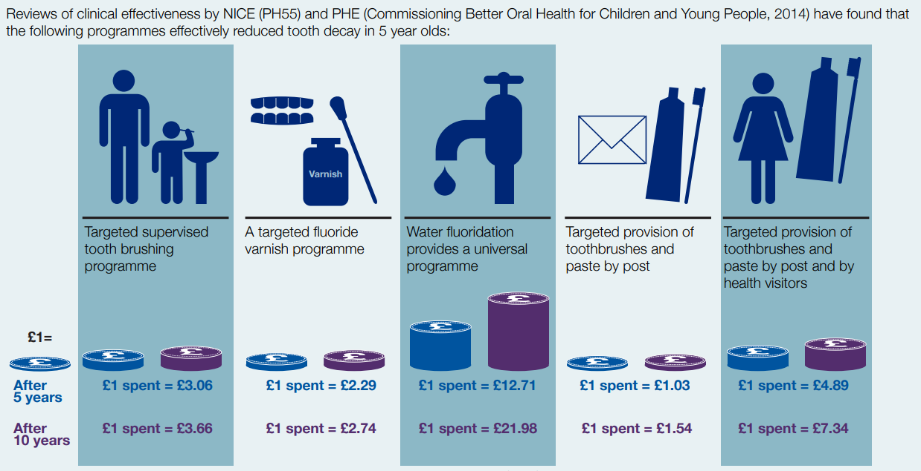
00
Figure 25: Return on investment of oral health improvement programmes of 0-5 year olds (2016). Reproduced from Public Health England

NICE recommendations for oral health
NICE public health guideline for local authorities on oral health makes recommendations on undertaking oral health needs assessments, developing a local strategy on oral health and delivering community-based interventions and activities. It aims to promote and protect people’s oral health by improving their diet and oral hygiene, and by encouraging them to visit the dentist regularly. The guideline has 21 recommendations; key points of those relevant to this OHNA are summarised below.
- Develop an oral health strategy based on an oral health need assessment. This should set out how the local authority and its partners will address the oral health needs of the local population as a whole (universal approaches) and of groups at high risk of poor oral health (targeted approaches).
- Ensure health and wellbeing and disease prevention policies for children and young people cover oral health. For example, policies covering excess weight, primary and secondary education, or health and wellbeing of looked after children.
- Incorporate oral health promotion in existing services for all children and young people at high risk of poor oral health, including making oral health care, including regular dental check-ups, an integral part of care planning – through self-care or clinical services.
- Ensure frontline health and social care staff can give advice on the importance of oral health, including understanding the links between health inequalities and oral health, and ensuring that frontline health and social care staff can advise carers on how to protect and improve the oral health and hygiene of those they care for.
- Commission training for health and social care staff working with children and young people at high risk of poor oral health.
- Early years:
  - Include oral health promotion in specifications for all early years services, and ensure all early years services provide oral health information and advice.
  - Ensure early years services provide additional tailored information and advice for groups at high risk of poor oral health.
  - Consider supervised tooth brushing schemes for nurseries in areas where children are at high risk of poor oral health. These should include providing free toothbrushes and fluoride toothpaste.
  - If a supervised tooth brushing scheme is not feasible, consider commissioning a community-based fluoride varnish programme for nurseries as part of early years services for children aged 3 years and older.
- Primary schools:
  - Raise awareness of the importance of oral health, as part of a 'whole-school' approach in all primary schools.
  - Introduce specific schemes to improve and protect oral health in primary schools in areas where children are at high risk of poor oral health.
  - Consider supervised tooth brushing schemes for primary schools in areas where children are at high risk of poor oral health. These should include providing free toothbrushes and fluoride toothpaste.
  - If a supervised tooth brushing scheme is not feasible, consider commissioning a community-based fluoride varnish programme for primary schools.
- Secondary schools: Promote a 'whole school' approach to oral health in all secondary schools, ensuring, wherever possible, that all school policies and procedures promote and protect oral health.

Views of stakeholders, parents, and carers

Views of stakeholders
As part of this OHNA, questionnaires were sent to stakeholders about their experience working within children and young people’s oral health. Stakeholders were primarily contacted via the Healthy Young People’s Network.
All respondents reported working with children and young people and/or families in Milton Keynes. Over 90% of respondents reported working with children looked after or care leavers, people affected by mental illness, people with learning disabilities, and people from minority ethnic groups. 88% of respondents reported working with people with physical disabilities, and two thirds of respondents reported working with vulnerable migrant groups, including refugees and asylum seekers; two thirds reported working with Gypsy, Roma and Travellers.
Three quarters of respondents reported regularly giving oral health information to service users, of whom most (85%) felt confident giving oral health advice to service users. 28% of respondents reported having oral health training in the last five years.
Key points from questionnaire responses have been divided into themes.

Oral health information and education
The majority of feedback was related to giving oral health information and advice to parents and families, particularly for children in early years age groups. Stakeholders reported that queries about oral health from parents and families were most often about:
- Tooth brushing, including what age to start, how many times to brush each day, what products to use, how much toothpaste to use, and how to manage when children do not want to brush their teeth.
- Use of dummies and bottles with teats during early years and into childhood, and giving bottles of milk at bedtime.
- What age a child needs to start seeing a dentist, and how to register with a NHS dentist.
Oral health promotion activities identified as working well included staff of Children and Family Centres being able to talk to families about oral health and promote “positive habits”, as well as using display boards in Centres to promote oral health. This was linked to broader health promotion activities in Centres such as promoting healthy diet and nutrition and having “sweet-free zones”.
Health Visitors were identified as being able to discuss oral health with families well at one- and two-year development reviews, and School Nursing teams able to deliver oral health promotion in schools to children aged five years and older. Collaboration between Children and Family Centres, and Health Visiting and School Nursing teams was also identified as working well.
A gap was highlighted in available information for parents of children and young people with special educational needs and disabilities (SEND) about finding a “’SEND friendly’ dentist or how to manage their child's oral health in general”. One respondent who worked with children and young people with SEND had put together their own fact sheet to share with parents to “cover this gap”. A gap was also reported in provision of information in multiple languages for families with English as an additional language, though specific languages were not suggested.
Some stakeholders said that more oral health training could be offered so staff could give advice with confidence.

Access to resources
“Some children to not have their own toothbrush”
Financial pressures were raised by multiple stakeholders, who reported that families were sometimes unable to prioritise spending money on new toothbrushes or toothpaste. Provision of free toothbrushing kits and brush exchange events were highlighted as interventions that worked well, including using them to encourage families to attend educational sessions and to talk about oral health. Provision of “freebies” and toothbrushing kits was also cited by several respondents as something that could be increased to improve oral health in the area.
One respondent suggested that resources could be made available to families at “pop-up” events in public places during school holidays, such as in Middleton Hall (an events area in the centre:MK shopping centre).

Access to services
The majority of respondents reported that families had difficulty accessing or were unable to register children with NHS dentist services. This was highlighted as an issue “even for vulnerable groups” who may have higher levels of need, such as children with SEND, children who are looked after, children who have child protection plans, and young people who are homeless.
Some stakeholders felt that signposting worked well, but it could be frustrating to recommend attending NHS services to families when no appointments or registrations were available. It was commented that children and families may not always be able to travel to dental services if they are not nearby, particularly for families living in more deprived areas.
It was observed by one respondent that once families were able to access NHS dentist, treatment was “fantastic”.

The views of parents and carers
To capture the views of parents and carers about oral health, four focus groups were carried out at Children and Family Centres in Milton Keynes during November and December 2023. Focus groups were held as part of a broader piece of work and covered topics of oral health, access to healthy food, cooking, and community support.
Questionnaires were also sent out to parents and carers via Children and Family Centres, SEND Participation inclusion group, and Ethnic Minority Achievement service, and to young people through the MK Youth Council. Notes from focus groups and questionnaire feedback have been analysed for emerging themes. Anonymised quotes are included to illustrate the themes where possible.

Oral health information and education
While parents and carers in focus groups were generally positive about having enough information and education about oral health, only 40% of parents and carers who responded to questionnaires reported feeling like they had enough information about looking after the dental heath of their child or children.
Many parents and carers reported looking for information from their dentist, or online (including NHS websites), with smaller numbers reporting looking to friends and family members, social groups and social media, and Children and Family centres for information.
When asked about where they would like to find information about children’s dental health, in addition to sources already mentioned, parents and carers identified nurseries, play groups, schools, GP practices, and the toothpaste aisle of shops. Some parents requested specific information about the benefits of manual versus electric toothbrushes, and different strengths of fluoride in toothpaste.
Feedback from young people aged 16-24 showed that respondents reported feeling like they knew how to look after their dental health, however, did not always report having been given information about oral health. Not all respondents reported knowing how diet and drinks can affect oral health.

Oral health care at home
Questionnaire responses showed that just over half (55%) of parents reported that their child brushed their teeth with fluoride toothpaste for at least two minutes twice a day, every day.
For families who said that daily toothbrushing was not a problem for their children, helpful approaches mentioned included children brushing their teeth at the same time as parents; making it fun by singing songs, playing games, “being silly”; using a mobile app with a timer; and reading books or using picture instructions to help children’s understanding of what to do.
Parents and carers who reported issues with children’s toothbrushing most frequently cited difficulties with introducing regular brushing with very young children, finding time during morning and evening routines, and children wanting to stop brushing before the two-minute time has passed. Some families also reported that children didn’t enjoy toothbrushing, didn’t like the taste of toothpaste, or did not always cooperate with parents when it was time to brush.
When children didn’t want to brush their teeth, many parents reported that they typically did not persevere with brushing on that occasion so as not to put the child off in the future. Other parents reported exploring brushing through play, coaching children through the process, and “powering through”.
Feedback from young people aged 16-24 included that:
“Sometimes I'm running late to school or I get home really late … so I'm too tired or don't have the time”
“I think I don’t understand why I need to do it for the full 2 minutes and so sometimes will just do 1 or something especially when I’m rushing in the morning”
“I think that it can be quite convenient to just skip brushing teeth or just brush it for a minute instead of two, I think it needs to be emphasised on the drawbacks of this”
Some families reported issues related to special educational needs and disabilities, particularly with sensory issues of using tooth paste and toothbrushes. Families with SEND expressed a need for additional support and information for maintain children’s oral health.

Access to NHS dental services
Families reported differing levels of access to NHS dentists, for both parents and children.
For families not able to access NHS dental services, the main issue reported was lack of local dentists accepting new NHS patients. One family reported not being able to register with a NHS dentist during the past five years, and were on a waiting list which will “probably be a two year wait”. Other families who weren’t registered said they “try weekly for an NHS dentist”, were “trying constantly”, and “try to get in as soon as more NHS spaces are advertised but they are always gone by the time they ask”.
Transport to dental services was highlighted as an issue. In one focus group, none of the families present had access to a car, so needed a dentist to be within walking distance from home. Accessing dentists by public transport was not always possible for families with young children because some bus services limit the number of prams and pushchairs allowed on board.

Conclusions
Oral health is an essential part of health and wellbeing for children and young people and affects quality of life. Prevalence of oral health problems continues to have a significant impact on the health and wellbeing of children in Milton Keynes; more than one in six children in Milton Keynes have visible dental decay by the age of five years.
Inequalities in oral health are considerable and entrenched. Children and young people in the most deprived areas experience significantly higher levels and severity of dental decay, as well as higher rates of hospital tooth extractions. Children with special educational needs and disabilities who have experience of decay tend to have more severe decay and have reported issues accessing appropriate care. There are also inequalities in oral health by ethnicity, with highest decay prevalence and severity seen in children of ‘other ethnic background’ and Asian/Asian British children. Health inequalities are systematic, unfair, and avoidable, and reduction of oral health inequalities is likely to require addressing the wider, social determinants of health.
Given the challenges with access to NHS dental services, it is particularly pertinent that children and young people are able to look after their oral health at home as well as they can, to prevent dental decay.
Evidence shows that there are interventions effective in preventing poor oral health in children and young people, and these should be provided in areas where children and at high risk of poor oral health. Interventions that can be provided locally include daily supervised tooth brushing programmes, provision of tooth brushing kits, application of fluoride gels to teeth, and community based oral health promotion activities. While water fluoridation is effective for both reducing prevalence of dental decay, and reducing oral health inequalities, the power to introduce water fluoridation schemes lies with the Secretary of State for Health and Social Care.

Recommendations
The recommendations below are based on the findings of this health needs assessment and focus on oral health improvement priorities within the remit of Local Authority Public Health, as set out in the Health and Social Care Act (2012).

Current oral health promotion offer
- Continue the provision existing oral health promotion activities through the 0-19 contract and Children and Family Centres.
- Embed systems to measure activity and impact of the current oral health promotion offer and undertake regular monitoring.
- Establish the level of need for increased oral health training for staff working with children, young people, and families.
- Relaunch the local Health & Wellbeing Awards for schools & settings

Oral health information for families
- Ensure oral health information resources are routinely available to families at locations including early years settings, primary schools, and GP practices.
- Ensure appropriate oral health information resources are available for parents and carers of children and young people with special educational needs and disabilities (SEND). These should include how to cope with sensory challenges when toothbrushing.
- Ensure culturally appropriate advice and information on oral health is available for families with babies and young children in groups at high risk of poor oral health. This may include, for example, providing oral health information in other languages.

Scoping additional service provision
- Scope provision of additional oral health improvement programmes in Milton Keynes, targeted towards children and young people at risk of poor oral health. This may include:

- Considering additional access points to offer free tooth brushing packs to offer to families in groups at high risk of poor oral health. For example, 0-19 services. Distribution of packs should be combined with information on when and how to brush teeth, a practical demonstration and information about local dental services.
- Commissioning supervised tooth brushing schemes for nurseries and primary schools in areas where children are at high risk of poor oral health, in line with NICE guidelines. These should include providing free toothbrushes and fluoride toothpaste.
- Commissioning a community-based fluoride varnish programme for nurseries as part of early years services for children aged 3 years and older, in line with NICE guidelines. In particular, children and young people with SEND.

Making oral health a strategic priority
- Use the findings of this OHNA to inform the development of a system-wide alliance to improve the oral health of children and young people in Bedfordshire and Milton Keynes
- Include oral health as a component of future joint strategic needs assessments for Milton Keynes City Council.
- Consider the need for additional dental epi for children and young people with SEND.

Appendices

Appendix 1: walking and public transport travel times to NHS dental services
00
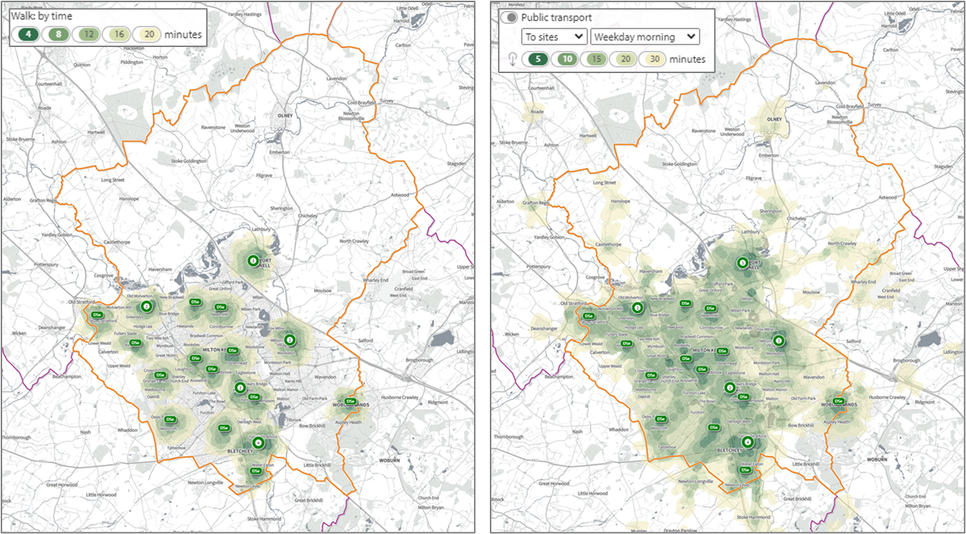
NHS dental services in Milton Keynes, with travel time radii added for up to 20 minutes walking (left), and up to 30 minutes public transport (right) around each location.
Each dental service is represented by a marker labelled DSe. Where there are multiple services in similar locations, a circle is shown, labelled with the corresponding number of services at that location. Orange boundary shows the extent of the Local Authority area.

References

Statistical neighbours of Milton Keynes, in order of ‘closeness’ are: Bedford Borough, Leeds, West Northamptonshire, Bexley, Reading, Thurrock, Swindon, Hertfordshire, Kent, and Derby.
Quintile of Index of Multiple Deprivation (IMD)
Rounded to the nearest 5
World Health Organisation (WHO). Oral Health. Available at: https://staging.afro.who.int/health-topics/oral-health
Office for Health Improvement and Disparities (2021). Delivering better oral health: an evidence-based toolkit for prevention. Available at: https://www.gov.uk/government/publications/delivering-better-oral-health-an-evidence-based-toolkit-for-prevention
Office for Health Improvement and Disparities (2023) National Dental Epidemiology Programme (NDEP) for England: oral health survey of 5 year old children 2022. Implications of Results. Available at: https://www.gov.uk/government/statistics/oral-health-survey-of-5-year-old-children-2022/national-dental-epidemiology-programme-ndep-for-england-oral-health-survey-of-5-year-old-children-2022#implications-of-results
Public Health England (2021). Inequalities in oral health in England: summary. Available at: https://www.gov.uk/government/publications/inequalities-in-oral-health-in-england/inequalities-in-oral-health-in-england-summary
Office for Health Improvement and Disparities (2023). Hospital tooth extractions in 0 to 19 year olds in 2022. Available at: https://www.gov.uk/government/statistics/hospital-tooth-extractions-in-0-to-19-year-olds-2022/hospital-tooth-extractions-in-0-to-19-year-olds-2022#:~:text=The%20caries%2Drelated%20tooth%20extraction,between%206%20and%2010%20years
NHS England (2023) National Cost Collection for the NHS. Available at: https://www.england.nhs.uk/costing-in-the-nhs/national-cost-collection/
NHS Digital (2021). Health Survey for England 2019: Supplementary analysis of dental health. Available at: https://digital.nhs.uk/data-and-information/publications/statistical/health-survey-for-england/2019/health-survey-for-england-2019-supplementary-analysis-on-dental-health
World Health Organisation (2017). Sugars and dental caries. Available at: https://www.who.int/news-room/fact-sheets/detail/sugars-and-dental-caries
Swan GE, Powell NA, Knowles BL, Bush MT, Levy LB. A definition of free sugars for the UK. Public Health Nutr. 2018 Jun;21(9):1636-1638.
Walsh T, Worthington HV, Glenny AM, Marinho VCC, Jeroncic A. Fluoride toothpastes of different concentrations for preventing dental caries. Cochrane Database of Systematic Reviews 2019, Issue 3.
NHS Digital (2022). Smoking Drinking and Drug Use among Young People in England, 2021. Available at: https://digital.nhs.uk/data-and-information/publications/statistical/smoking-drinking-and-drug-use-among-young-people-in-england/2021/part-1-smoking-prevalence-and-consumption#pupils-who-are-regular-smokers
Sheiham A, Watt RG. The common risk factor approach: a rational basis for promoting oral health. Community Dent Oral Epidemiol. 2000 Dec;28(6):399-406.
Watt RG, Sheiham A. Integrating the common risk factor approach into a social determinants framework. Community Dent Oral Epidemiol. 2012 Aug;40(4):289-96.
Office for Health Improvement and Disparities (2022). Child oral health: applying All Our Health. Available at: https://www.gov.uk/government/publications/child-oral-health-applying-all-our-health/child-oral-health-applying-all-our-health
NHS England (2022). Core20PLUS5 – An approach to reducing health inequalities for children and young people. Available at: https://www.england.nhs.uk/about/equality/equality-hub/national-healthcare-inequalities-improvement-programme/core20plus5/core20plus5-cyp/
HM Revenue and Customs (2016). Soft Drinks Industry Levy. Available at: https://www.gov.uk/government/publications/soft-drinks-industry-levy/soft-drinks-industry-levy
Rogers NT, Conway DI, Mytton O, et al. Estimated impact of the UK soft drinks industry levy on childhood hospital admissions for carious tooth extractions: interrupted time series analysis. BMJ Nutrition, Prevention & Health 2023
Estimate of the population for the UK, England, Wales, Scotland and Northern Ireland. Office for National Statistics. Accessed 16.11.2023. https://www.ons.gov.uk/peoplepopulationandcommunity/populationandmigration/populationestimates/datasets/populationestimatesforukenglandandwalesscotlandandnorthernireland
Milton Keynes City Council. Milton Keynes JSNA. Available at: https://bmkjsna.org/milton-keynes/jsna/population-place/
Department for Work and Pensions (2023). Children in low income families: local area statistics 2014 to 2022. Available at: https://www.gov.uk/government/statistics/children-in-low-income-families-local-area-statistics-2014-to-2022
Ministry of Housing, Communities & Local Government (2019). English indices of deprivation 2019. Available at: https://www.gov.uk/government/statistics/english-indices-of-deprivation-2019
GOV.UK (2022) UK population by ethnicity. GOV.UK. Available at: https://www.ethnicity-facts-figures.service.gov.uk/uk-population-by-ethnicity
Department of Health and Social Care (2023). Shape atlas. © Copyright HM Government. 2023. Available at: https://app.shapeatlas.net/
NHS Digital (2023) NHS Dental Statistics for England, 2022-23, Annual Report. Available at: https://digital.nhs.uk/data-and-information/publications/statistical/nhs-dental-statistics/2022-23-annual-report
Smith, G., Gidlow, C., Davey, R. et al. What is my walking neighbourhood? A pilot study of English adults' definitions of their local walking neighbourhoods. Int J Behav Nutr Phys Act 7, 34 (2010).
NHS (2023). How to find an NHS dentist. Available at: https://www.nhs.uk/nhs-services/dentists/how-to-find-an-nhs-dentist/
NHS (2023). Find a dentist. Available at: https://www.nhs.uk/service-search/find-a-dentist
NHS England (2023). GP Patient Survey Dental Statistics; January to March 2023, England. Available at: https://www.england.nhs.uk/statistics/2023/07/13/gp-patient-survey-dental-statistics-january-to-march-2023-england/
NHS England (2023). Dental commissioning policies and procedures. Available at: https://www.england.nhs.uk/primary-care/dentistry/dental-commissioning/dental-policies-and-procedures/
Milton Keynes Council. Specialist dental services. Available at: https://www.milton-keynes.gov.uk/schools-and-lifelong-learning/SEND/send-directory-information/specialist-dental-services
Oxford Health NHS Foundation Trust. Thames Valley Community Dental Services. Available at: https://www.oxfordhealth.nhs.uk/tvcds/
Office for Health Improvement and Disparities (2023). National Dental Epidemiology Programme (NDEP) for England: oral health survey of 5 year old children 2022. Available at: https://www.gov.uk/government/statistics/oral-health-survey-of-5-year-old-children-2022/national-dental-epidemiology-programme-ndep-for-england-oral-health-survey-of-5-year-old-children-2022
Public Health England (2018). Oral health survey of children attending special support schools. Available at: https://www.gov.uk/government/statistics/oral-health-of-5-and-12-year-old-children-attending-special-support-schools-in-england-2014#full-publication-update-history
Office for Health Improvement and Disparities (2023). Methods for calculating numbers and rates of hospital tooth extractions. Available at: https://www.gov.uk/government/publications/analysis-of-tooth-extractions-in-hospital-methods-and-data-quality/methods-for-calculating-numbers-and-rates-of-hospital-tooth-extractions
NHS Digital (2023). NHS Dental Statistics. Available at: https://digital.nhs.uk/data-and-information/publications/statistical/nhs-dental-statistics
NHS (2021). What is included in each NHS dental band charge? Available at: https://www.nhs.uk/nhs-services/dentists/dental-costs/what-is-included-in-each-nhs-dental-band-charge/
Department for Education (2024). Local authority interactive tool (LAIT). Available at: https://www.gov.uk/government/publications/local-authority-interactive-tool-lait
Milton Keynes City Council. HYPN Events and training. Available at: https://www.milton-keynes.gov.uk/health-and-wellbeing/hypn-events-and-training
Milton Keynes City Council. HYPN Support Available. Available at: https://www.milton-keynes.gov.uk/health-and-wellbeing/healthy-young-peoples-network/hypn-support-available
Milton Keynes City Council. Children’s Health and Wellbeing. Available at: https://www.milton-keynes.gov.uk/health-and-wellbeing/childrens-health-and-wellbeing
Public Health England. Science lesson PowerPoint – Keeping our teeth healthy. Available at: https://campaignresources.phe.gov.uk/schools/resources/keeping-our-teeth-healthy-lesson-plans
Brush DJ [website]. Available at: https://www.brushdj.com/
Department of Health and Social Care (2021). Top Tips For Teeth. Available at: https://campaignresources.dhsc.gov.uk/campaigns/top-tips-for-teeth/
NHS England (2024). Children’s Oral Health Advice. Available at: https://www.e-lfh.org.uk/programmes/childrens-oral-health/#:~:text=Top-,About%20the%20Children%27s%20Oral%20Health%20programme,part%20of%20every%20child%27s%20wellbeing.
Milton Keynes City Council (2023). Health and Wellbeing Awards. Available at: https://www.milton-keynes.gov.uk/health-and-wellbeing/health-and-wellbeing-awards#:~:text=What%20are%20the%20Health%20and,centres%2C%20nurseries%2C%20and%20schools.
Institute of Health Equity (2010). Fair Society, Healthy Lives (The Marmot Review). Available at: https://www.instituteofhealthequity.org/resources-reports/fair-society-healthy-lives-the-marmot-review
Arora A, Kumbargere Nagraj S, Khattri S, Ismail NM, Eachempati P. School dental screening programmes for oral health. Cochrane Database of Systematic Reviews. 2022 Jul 27;7(7)
National Institute for Health and Care Excellence (2014). Oral health: local authority oral health improvement strategies Evidence review 1: review of evidence of the effectiveness of community-based oral health improvement programmes and interventions. Available at: https://www.nice.org.uk/guidance/ph55/evidence
Marinho VCC, Chong L-Y, Worthington HV, Walsh T. Fluoride mouthrinses for preventing dental caries in children and adolescents. Cochrane Database of Systematic Reviews 2016, Issue 7.
Riggs E, Kilpatrick N, Slack‐Smith L, Chadwick B, Yelland J, Muthu MS, Gomersall JC. Interventions with pregnant women, new mothers and other primary caregivers for preventing early childhood caries. Cochrane Database of Systematic Reviews 2019, Issue 11.
Marinho VCC, Worthington HV, Walsh T, Chong L-Y. Fluoride gels for preventing dental caries in children and adolescents. Cochrane Database of Systematic Reviews 2015, Issue 6.
Local Government Association (2019). A Whole Systems Approach to Tackling Tooth Decay. Available at: https://www.local.gov.uk/sites/default/files/documents/15.70%20Whole%20systems%20approach%20to%20tackling%20childhood%20tooth%20decay_03_1%20WEB.pdf
Waldron C, Nunn J, Mac Giolla Phadraig C, Comiskey C, Guerin S, van Harten MT, Donnelly‐Swift E, Clarke MJ. Oral hygiene interventions for people with intellectual disabilities. Cochrane Database of Systematic Reviews 2019, Issue 5.
Iheozor‐Ejiofor Z, Worthington HV, Walsh T, O'Malley L, Clarkson JE, Macey R, Alam R, Tugwell P, Welch V, Glenny AM. Water fluoridation for the prevention of dental caries. Cochrane Database of Systematic Reviews 2015, Issue 6.
Public Health England (2018). Water Fluoridation: Health monitoring report for England 2018. Available at: https://www.gov.uk/government/publications/water-fluoridation-health-monitoring-report-for-england-2018
UK Government (2022) Health and Care Act 2022 c. 31. Available at: https://www.legislation.gov.uk/ukpga/2022/31/part/6/crossheading/fluoridation-of-water-supplies/enacted
Public Health England (2016). A rapid review of evidence on the cost-effectiveness of interventions to improve the oral health of children aged 0 to 5 years. Available at: https://www.gov.uk/government/publications/improving-the-oral-health-of-children-cost-effective-commissioning
National Institute for Health and Care Excellence (2014). Economic modelling - RX058 - Economic analysis of oral health improvement programmes and interventions. Available at: https://www.nice.org.uk/guidance/ph55/Evidence
Public Health England (2016). Return on investment of oral health improvement programmes for 0 to 5 year olds: infographic. Available at: https://www.gov.uk/government/publications/improving-the-oral-health-of-children-cost-effective-commissioning
National Institute for Health and Care Excellence. 2014. Oral health: local authorities and partners. Available at: https://www.nice.org.uk/guidance/ph55

