


Milton Keynes Drug and Alcohol Needs Assessment 2022/23: Executive Summary

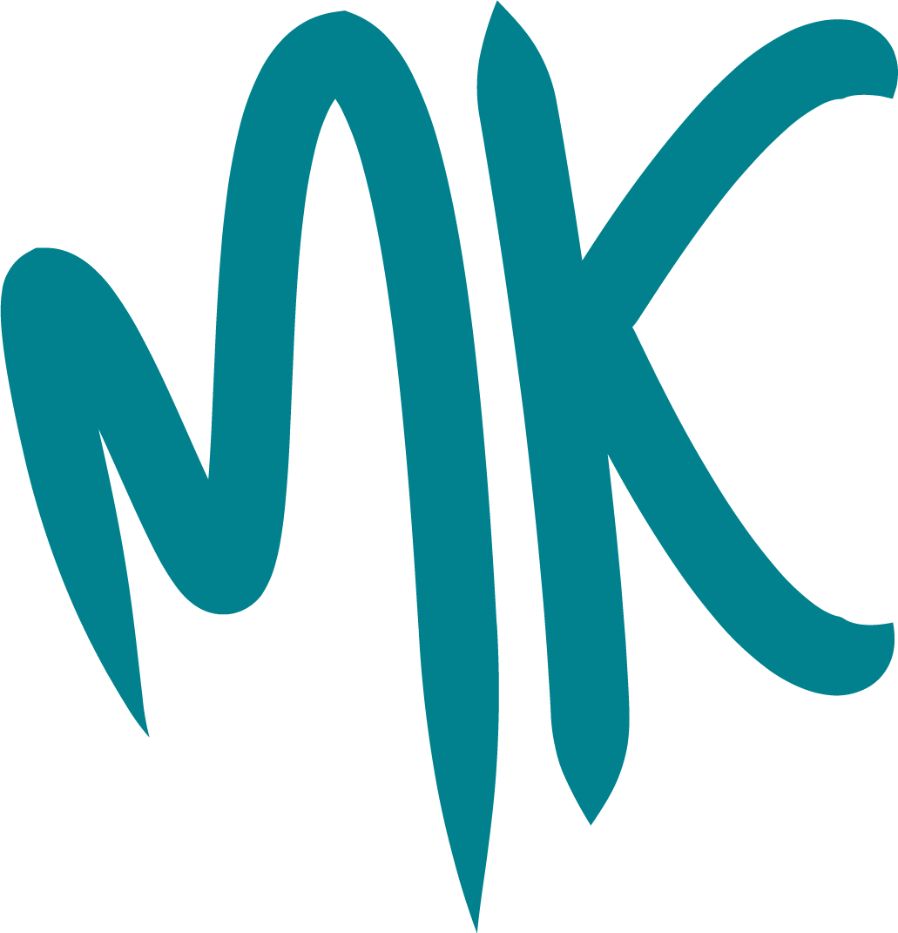

Introduction
The Milton Keynes Drug and Alcohol Needs Assessment was undertaken as part of the local response to the 2021 10-year national drug strategy and as a requirement by the Governments Joint Combating Drugs Unit. The MK Together Safeguarding Partnership has taken on the function of the Combatting Drugs Partnership for Milton Keynes. The needs assessment serves to provide an analysis of current alcohol and drug-related harms and benchmark understanding of local activities that contribute to the delivery of the three strategic priorities of the National Drug Strategy. This Needs Assessment will inform the local strategy and delivery plan for Milton Keynes CDP, the delivery of which will be overseen by the MK Together Safeguarding Partnership.
After summarising alcohol and drug-related harms in Milton Keynes, this needs assessment benchmarks progress towards the following key priorities outlined in the national strategy:
- deliver a world-class treatment and recovery system; and
- achieve a generational shift in demand for drugs. Analysis for the third priority, ‘break drug supply chains’ is still in development and will be added to the drug and alcohol needs assessment once completed.
This needs assessment draws on the latest national and local data from a wide range of sources and includes engagement with many stakeholders, including treatment and recovery service providers, children and family centres, education services, youth offending services, and the criminal justice system.

An overview of alcohol and drug-related harms in Milton Keynes
There is a higher unmet treatment need for all drug and alcohol groups in Milton Keynes compared with England and local comparators. Nevertheless, perhaps because prevalence rates are relatively low, Milton Keynes performs better than comparators in some indicators of alcohol and drug-related harms, including hospital admissions.
However, rates of alcohol-specific and alcohol-related mortality are similar in Milton Keynes compared with England. Concerningly, deaths from drug misuse have increased across England over the reporting period. In Milton Keynes the death rate due to drug misuse has increased by 50% from 2014 to 2020.
There are clear inequalities in the harms due to alcohol misuse in Milton Keynes. Bletchley East and Woughton & Fishermead both contain neighbourhoods ranked in the 3% most deprived areas in England and these two wards also have the highest rates of alcohol-related hospital admissions in Milton Keynes.
Prevalence of drug and alcohol misuse may be underestimated in black and minority ethnic communities and there is an under-representation of these groups in treatment in Milton Keynes.
Drug and/or alcohol misuse appears to be higher among lesbian, gay, bisexual, transgender, and queer (LGBTQ+) groups. A higher percentage of respondents in Milton Keynes reported their gender identity is different from sex registered at birth in the 2021 Census compared with the average across England (0.62% compared with 0.54%). However, data on sexual orientation and gender identity of people in treatment is not collected in Milton Keynes or nationally, so it is unknown how these groups are represented in treatment services.

Delivering a world-class treatment and recovery system
The client profile in drug and alcohol treatment services is different to that of the general population in Milton Keynes, with a larger proportion of males and white clients and, in the case of opiate users, a growing proportion of clients aged over 50. Clients most often self-refer or are referred by family or friends into treatment and there is a target to ensure that all clients are seen at least within three weeks of referral, but often people seeking treatment are seen much sooner.
Treatment outcomes vary between drug groups and in relation to comparator areas. Of note, there have been sustained improvements in the rates of early unplanned exits from drug and alcohol treatment in Milton Keynes over the last 12 months, particularly among non-opiate clients.
Opiate clients remain in treatment the longest and experience the lowest rates of successful completion of treatment. This is due to a number reasons, including an ageing cohort with complex comorbidities and the increasing length of time clients have been using opiates (as relatively few individuals are taking up the illicit use of these substances).
The proportion of clients no longer injecting or no longer drinking alcohol at treatment end in Milton Keynes are similar to those of comparators. While the rate of successful completions among opiate clients is similar or higher than that of comparators, the rates of successful completions among non-opiate clients and alcohol clients in Milton Keynes are significantly lower. This could relate to the higher mental health treatment need among clients in Milton Keynes. On the other hand, there has been sustained improvement in successful completions among young people in Milton Keynes with a rate for the most part higher than that of comparators since Q1 2020/21.
Smoking prevalence is higher among clients entering drug and alcohol treatment compared with the general adult population in Milton Keynes and is particularly high among opiate clients (71%). There is no data available on the proportion of clients receiving smoking cessation interventions, likely due to data collection issues.
Co-occurring mental health and substance misuse conditions are very common and have risen substantially over the last five years, with around three-quarters of drug and alcohol clients entering treatment in Milton Keynes reporting having a mental health treatment need in 2021/22.
Drug and alcohol clients, particularly opiate clients, experience a high prevalence of housing need and unemployment. While housing problems appear largely resolved for clients completing treatment, there remain high rates of unemployment among drug and alcohol clients – much higher than the rate seen in Milton Keynes’ general population. Similarly, the proportion of 16-17 year-olds in treatment who are not in employment, education or training (NEET) is much higher than that of all 16-17 year-olds in Milton Keynes.
The number of clients receiving recovery support has increased in Milton Keynes over the last 18 months, even though recovery services have been impacted by falling numbers of volunteers due to the costs of living crisis and volunteers with lived experience seeking paid employment. .

Achieving a generational shift in the demand for drugs
The prevention of drug and/or alcohol misuse requires wide cross-sectoral collaboration at both the national level and the local level. While evidence is lacking in some areas, many interventions protecting children and young people, and adults from substance misuse and other vulnerabilities, can already be identified and implemented.
Prevention of drug and/or alcohol misuse starts with reducing inequalities and addressing the building blocks of health. This includes ensuring access to education, training and employment.
Children and young people face changing vulnerabilities throughout their life course. There are evidence-based interventions at every developmental stage, many of which are focused on supporting healthy social and cognitive development. Health services and children and family centres provide most of the interventions targeted at early childhood.
Trauma, adverse childhood experiences (ACEs) and poor mental health are all risk factors for future drug and alcohol dependency. Evidence-based support for young people who have had will also help this at-risk population. Child and adolescent mental health services (CAMHS) are important across all age groups, and it is possible that there is an unmet mental health need in Milton Keynes.
Many of the interventions to prevent the onset of drug use among children and young people take place in schools. The Department for Education statutory guidance on personal, social, health and economic (PSHE) education supports several interventions, so too will drug and alcohol policies, and policies to keep children in school.
Fewer students are permanently excluded from school in Milton Keynes compared with England and its local comparator, Bedford. A small proportion of these exclusions relate to drugs and alcohol. However, despite having a lower rate of permanent school exclusions, the proportion of 16-17 year-olds who are NEET in Milton Keynes is higher than that of Bedford.
Diversion schemes for drug and alcohol-related offences are provided to both young people and adults in Milton Keynes. The Milton Keynes Youth Offending Team provide a Youth Diversion and Prevention Service which includes a range of support, based on an individual’s needs. Adults are referred to Druglink for an education course through a community resolution programme.

Recommendations
The table below provides a summary of the key findings and recommendations to address these. The recommendations have been aligned to the National Combating Drugs Outcomes Framework.
Strategic outcomes
Reducing drug use  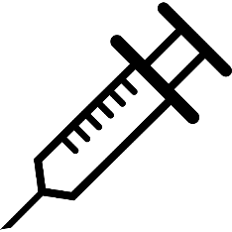 | What we know | Recommendation | Key Partners
 | Trauma is a significant factor in drug and alcohol misuse and in the development of dependency in adulthood.  While local and national data is limited, there is clear international evidence on interventions to prevent the onset of drug and alcohol use among children, young people and adults throughout the life course. | Implement an effective prevention system of universal, targeted and indicated approaches and interventions to reduce drug use using the UN Office of Drugs and Crime and World Health Organisation international standards as a structured approach. | Public Health  NHS services  Children’s Social Care  Schools  Police  Youth Offending Service  Probation Services
 | Prenatal drug and alcohol exposure can have life-long consequences, impacting on behavioural, social, and emotional development. The evidence demonstrates that interventions targeting pregnant women are effective in reducing drug use among pregnant women and their children. While Addiction Recovery Community Milton Keynes (ARC-MK) prioritise parents and pregnant women and attend a monthly perinatal MDT, ARC-MK does not have a formal pregnancy pathway. | Establish a formal Pregnancy Pathway for drug and alcohol treatment services aligned to pre-birth procedures, specifically the Recognising Vulnerabilities of Children in Particular Circumstances Procedure. | ARC-MK  Central and North West London NHS Foundation Trust  Milton Keynes Hospital University Hospital Midwives  Primary care
 | A significant proportion of the unmet drug and alcohol treatment need in Milton Keynes includes parents and carers. Parent/carer substance misuse can result in adverse childhood experiences, which increase the risk of harm from mental health issues and drug and/or alcohol misuse. | Increase access to whole family interventions and support to reduce risks and impacts associated with parental substance misuse. This includes the further provision of the Moving Parents and Children Together Programme (M-PACT). | ARC-MK  Milton Keynes Young People’s Drug and Alcohol Service (MKYPDAS)  Children’s Social Care
 | Emotional and behavioural disorders are associated with a higher risk of substance use in adolescence and later in life. The evidence demonstrates that supporting children, adolescents and parents to address emotional and behavioural disorders as early as possible is an important intervention strategy. However, there is likely a high early mental health intervention unmet need for children and young people in Milton Keynes. | Partners of the Milton Keynes Deal address early mental health intervention service gaps, recognising this as a priority. This includes a review and analysis of services and gaps within the “Getting Help” area of the THRIVE Framework. | Child and adolescent mental health service (CAMHS)
 | While Milton Keynes has a lower rate of permanent school exclusions than comparators, drug and alcohol use accounted for 14.3% of exclusions in 2019/20. Excluded children experience much higher rates of vulnerabilities such as poverty and mental health problems. They are at greater risk of exploitation and are more likely to be unemployed, develop severe mental health problems, and go to prison. | Ensure all schools in Milton Keynes implement a drug, alcohol and tobacco policy and that pupils access support for their drug and alcohol use as an alternative to exclusion. | Schools  Public Health  Children’s Social Care
 | Unemployment is both a risk factor for, and an impact of, drug and alcohol misuse. Over half of all adults entering drug and alcohol treatment in Milton Keynes are unemployed – much higher than the rate for the general population in Milton Keynes, which was 3.8% in August 2022. Five workplaces in Milton Keynes have so far expressed an interest in working towards the bronze Alcohol and Substance misuse Milton Keynes Healthy Workplace Standard. | Increase access to information and support in the workplace to help identify need and support employees at risk of, or experiencing harm from substance misuse and help them remain in employment. | Public Health  Workplaces
Reducing drug-related deaths and harm   | What we know | Recommendation | Key Partners
 | There has been a steep decline in estimated alcohol-related hospital admissions in Milton Keynes since 2017/18. However, over the same period, there has been no change in estimated alcohol-related mortality and an increase in alcohol-specific mortality. There also remains a high level of unmet need for people with alcohol misuse in Milton Keynes: of Milton Keynes’ 16 CIPFA neighbours, Milton Keynes ranked 14th for unmet need for alcohol misuse in 2020/21 (where 1 is the best and 16 is the worst). A better understanding of the local data and how to prevent morbidity and mortality due to alcohol misuse is needed. | Conduct an audit of alcohol-related hospital admissions as part of a wider approach to better understand the complexities of alcohol-related deaths to identify opportunities for prevention, early intervention and support. | Public Health  Milton Keynes University Hospital Trust  Partnership support
 | The rate of deaths from drug misuse (which include drug poisonings and mental and behavioural disorders due to psychoactive substance use) in Milton Keynes has risen by 50% from 2014 to 2020. While comparators have also seen an increase, the rise has been steeper in Milton Keynes over this period. Of Milton Keynes’ 16 CIPFA neighbours, Milton Keynes ranked 7th in 2020/21 (where 1 is the best and 16 is the worst). | Implement a partnership plan for the reduction of drug-related deaths and alcohol-related deaths, using findings from annual Drug and Alcohol Related Death Reviews. | Public Health  Partnership support
 | Hepatitis B (HBV) vaccination and early hepatitis C (HCV) detection and treatment can help eliminate these viruses and their health consequences. 68.3% of eligible clients in treatment in Milton Keynes received an HBV vaccine and 73.0% of eligible clients accepted an HCV test in Q1 2022/23. Milton Keynes is performing well in relation to its CIPFA neighbours, ranking 2nd for HBV vaccination and 3rd for HCV testing in 2021/22 (where 1 is the best and 16 is the worst). | Increase the proportion of people in treatment screened and vaccinated for HBV and completing treatment for HCV. | ARC-MK  Public Health
 | Smoking prevalence is higher among clients entering drug and alcohol treatment compared with the general adult population in Milton Keynes and is particularly high among opiate clients (71%). There is no data available on the proportion of clients receiving smoking cessation interventions, likely due to data collection issues. | Increase the provision of smoking cessation interventions in drug and alcohol treatment and improve the data collection on smoking interventions offered and implemented. | ARC-MK  Public Health
Intermediate outcomes
Increasing engagement in drug treatment   | What we know | Recommendation | Key Partners
 | The estimated percentage of people with drug and/or alcohol misuse not in treatment is higher in Milton Keynes than the national average, and higher than the estimates for the majority of Milton Keynes CIPFA neighbours in 2020/21. The vast majority of adults entering drug and alcohol treatment self-refer or are referred by family and friends. A smaller proportion are referred by health and social care services and this has likely been impacted by the COVID-19 pandemic. | Embed a partnership approach that is informed by lived experience to identify need and support individuals into substance misuse treatment. | Public Health  ARC-MK  Adult Social Care  Children’s Social Care  Housing  Primary Care  Police
 | There are inequalities in drug and alcohol-related harms and in treatment engagement. The two wards with the highest rates of alcohol-related hospital admissions in Milton Keynes are Bletchley East and Woughton & Fishermead, which are ranked in the 3% most deprived areas in England. Prevalence of drug and alcohol misuse may be underestimated in black and minority ethnic communities and there is an under-representation of these groups in treatment in Milton Keynes. Drug and/or alcohol misuse appears to be higher among lesbian, gay, bisexual, transgender, and queer (LGBTQ+) groups. A higher percentage of respondents in Milton Keynes reported their gender identity is different from sex registered at birth in the 2021 Census compared with the average across England (0.62% compared with 0.54%). However, data on sexual orientation and gender identity of people in treatment is not collected in Milton Keynes or nationally, so it is unknown how these groups are represented in treatment services. | Conduct a lived experience project to understand barriers to accessing drug and alcohol treatment in these communities to reduce inequality in access among these groups. | Public Health
 | Successful completion rates for non-opiate and alcohol clients are lower in Milton Keynes than in comparator areas. | Commissioners and provider to undertake benchmark research of comparator areas to gain further insight into local successful completion rates and implement any relevant learning. | ARC-MK  Public Health  Comparator commissioners and providers
Improving drug recovery outcomes   | What we know | Recommendation | Key Partners
 | Co-occurring mental health and substance misuse conditions are very common and have risen substantially over the last five years, with around three-quarters of drug and alcohol clients entering treatment in Milton Keynes reporting having a mental health treatment need in 2021/22. | Embed a partnership approach to identify people with mental health conditions at an earlier stage to reduce the likelihood of using substances to manage their condition | Public Health  Community mental health services  ARC-MK
 | Over half of all adults entering drug and alcohol treatment in Milton Keynes are unemployed – much higher than the rate for the general population in Milton Keynes, which was 3.8% in August 2022. The rate of employment at treatment completion remains low, although is similar to that of comparator areas. | Roll out Individual Placement Support for individuals in treatment when this funding becomes available via OHID/DWP | Support Advice Mentoring and Advocacy Service (SAMAS)  Adult Social Care  Job Centre Plus  ARC-MK
 | 37% of 16-17-year-olds entering drug and alcohol treatment in 2019/20 were not in employment, education or training (NEET). This compares to a rate of 4.7% for all 16-17-year-olds in Milton Keynes. | Deliver targeted drug and alcohol education sessions to children and young people who are NEET to reduce their likelihoods of using or experiencing harms from substances. | MKYPDAS  NEET strategy partners
 | The Probation Link-Work programme previously supported people on probation with housing, treatment, and other needs but this has now ceased. The Support Advice Mentoring and Advocacy Service (SAMAS) which provide per led recovery support in the community, supports Probation clients in recovery. Currently, referrals to the service are relatively low yet the service could provide similar support to the Probation Link-Work programme. | Develop joint working relationship and implement referral pathways between probation and SAMAS to strengthen the support offered. | Probation Service  SAMAS

